 | Syrian Arab Republic Syrian Private University Faculty of Informatics Engineering Department of Software Engineering and Information Systems

Health Insurance Management System
Applications Project - Software Engineering Department

Prepared by
Baraa Alhayek
Abdulaziz Alhaj

Supervised by
Dr. Kadan Jomaa Eng. Maya Al Ahmad

July 2026

Table of Contents
Abstract 8
الملخص 9
Chapter 1: Introduction 11
1.1 Project Overview and Background 12
1.2 Problem Statement and Practical and Academic Importance 12
1.3 Project Objectives 13
1.4 Project Scope, Limitations, and Assumptions 14
1.5 Project Contribution to Knowledge and Domain 14
1.6 Research Methodology and Scientific Methods Used 15
1.7 Report Structure 15
1.8 Basic Definitions and Concepts 17
Chapter 2: Development Methodology and Project Management 18
2.1 Introduction 19
2.2 Selected Development Methodology and Justification 19
2.3 Project Schedule 20
2.4 Risk Management 20
2.5 Team Roles and Task Distribution 22
2.6 Quality Management in the Project 22
2.7 Project Management Tools Used 23
2.8 Monitoring and Continuous Evaluation Mechanisms 24
2.9 Software Configuration Management (SCM) 24
Chapter 3: Theoretical Framework and Previous Studies 26
3.1 Introduction 27
3.2 Previous Studies in Similar and Intelligent Systems 27
3.2.1 Digital Health Insurance Management Systems 27
3.2.2 Digital Claims Processing 27
3.2.3 Digital Claims Management in Health Financing 28
3.2.4 Digital Technologies in Government-Supported Health Insurance 28
3.2.5 Health Insurance Claims Management Challenges 28
3.3 Modern Technologies and Frameworks in the Field 29
3.4 Comparative Analysis of Existing Systems and Products 30
3.5 Research Gap and Proposed Innovation 30
3.6 Theoretical Framework and Reference Studies 31
3.7 Current and Future Trends in the Field 32
Chapter 4: Requirements Analysis and System Modeling 33
4.1 Introduction 34
4.2 Feasibility Study 34
4.2.1 Technical Feasibility 34
4.2.2 Economic Feasibility 34
4.2.3 Operational Feasibility 34
4.3 Requirements Collection 35
4.4 Stakeholders Identification and Needs Analysis 35
4.5 Functional Requirements 36
4.6 Non-Functional Requirements 37
4.7 Requirement Prioritization 38
4.8 UML Diagrams for Requirements 39
4.8.1 Use Case Diagram 39
4.8.2 Use Case Descriptions 39
4.8.3 Activity Diagrams 47
4.8.4 Sequence Diagrams 50
4.8.5 Class Diagram 54
4.9 Modeling According to the Selected Methodology 55
4.10 Requirements Analysis and Documentation 55
4.11 Conclusion 57
Chapter 5: Architectural and Detailed Design 57
5.1 Introduction 58
5.2 High-Level System Design 58
5.2.1 System Block Diagram 58
5.2.2 Architectural Design Pattern 59
5.3 Database Design 59
5.3.1 Entity-Relationship Diagram 59
5.3.2 Relational Schema 60
5.3.3 Database Constraints 69
5.4 API and Interface Design 70
5.4.1 Authentication and Account Registration 70
5.4.2 Insurance Plan and Coverage Management 72
5.4.3 Subscription Management 72
5.4.4 Reimbursement Management 73
5.4.5 Eligibility Verification 74
5.5 Security and Authorization Design 75
5.5.1 Authentication Design 75
5.5.2 Role-Based Authorization 75
5.5.3 Password and Session Security 75
5.5.4 Input and File Upload Security 76
5.5.5 Data Protection and Error Handling 76
5.6 Chapter Summary 76
Chapter 6: Development Environment and Software Implementation 77
6.1 Programming Tools and Libraries 78
6.2 Development Environment 79
6.2.1 Development Environment Configuration 79
6.3 Programming Languages and Frameworks 79
6.3.1 TypeScript 79
6.3.2 Next.js 80
6.3.3 React 80
6.3.4 Prisma ORM 80
6.3.5 PostgreSQL 80
6.3.6 Tailwind CSS 80
6.3.7 Auth.js 80
6.3.8 Zod 80
6.4 Database Server and Operating System 81
6.4.1 Database Server 81
6.4.2 Operating System 81
6.5 Project Dependencies 81
6.5.1 Main Project Dependencies 81
6.6 Version Control 82
6.6.1 Git Repository 82
6.6.2 GitHub Repository 82
6.7 Continuous Integration and Deployment (CI/CD) 82
6.8 Testing Environment 82
6.9 Software Implementation 83
6.9.1 Project Structure 83
6.9.2 Authentication Module 84
6.9.3 Insurance Plan Management Module 85
6.9.4 Subscription Management Module 86
6.9.5 Reimbursement Management Module 87
6.9.6 Data Access Layer Implementation 88
6.9.7 User Interface Implementation 88
6.10 Chapter Summary 95
Chapter 7: Testing and Evaluation 96
7.1 Test Plan 97
7.2 Types of Testing 97
7.2.1 Module and Increment Testing 97
7.2.2 Integration Testing 97
7.2.3 System Testing 97
7.3 Test Diagrams 98
7.3.1 Functional Test Cases 98
7.3.2 Test Result Diagram 100
7.4 Test Results and Analysis 100
7.5 Quality Metrics 101
7.6 User Testing 101
7.7 Chapter Summary 102
Chapter 8: Results and Analysis 103
Introduction 104
8.1 System Implementation Results 104
8.1.1 Main Implemented Functions 104
8.1.2 Operational Results of the Implemented Interfaces 105
8.2 Comparative Analysis with Existing Systems 105
8.3 Achievement of Project Objectives 106
8.4 Strengths and Weaknesses Analysis 107
8.5 Key Performance Indicators (KPIs) 108
8.6 Chapter Summary 108
Conclusion 109

List of Tables
Table 1. Project Risk Management 18
Table 2. Team Roles and Task Distribution 19
Table 3. Comparative Analysis of Existing Systems and Products 27
Table 4. Stakeholders and Their Needs 32
Table 5. Non-Functional Requirements 34
Table 6. Functional Requirements Prioritization 35
Table 7. Use Case Description: Create New Account 37
Table 8. Use Case Description: Create Medical Service Provider Account 37
Table 9. Use Case Description: Role-Based Login 38
Table 10. Use Case Description: Add New Health Insurance Plan 38
Table 11. Use Case Description: Define Covered Services and Coverage Percentages 39
Table 12. Use Case Description: Activate Subscriber Subscription 39
Table 13. Use Case Description: View Subscription Details and Health Coverage 40
Table 14. Use Case Description: Submit New Medical Reimbursement Request 40
Table 15. Use Case Description: Upload Invoice or Medical Document 41
Table 16. Use Case Description: Track Reimbursement Request Status 41
Table 17. Use Case Description: Review Reimbursement Requests 42
Table 18. Use Case Description: Approve Reimbursement Request 42
Table 19. Use Case Description: Reject Reimbursement Request with Reason 43
Table 20. Use Case Description: Verify Subscriber Eligibility and Status 43
Table 21. System Modeling According to the Incremental Methodology 53
Table 22. Requirements Traceability Matrix 54
Table 23. User Relational Schema 58
Table 24MedicalProviderProfile Relational Schema 59
Table 25. Insurance Plan Relational Schema 60
Table 26 . Medical Service Relational Schema 61
Table 27. Insurance Subscription Relational Schema 62
Table 28. Plan Coverage Relational Schema 63
Table 29. Reimbursement Request Relational Schema 64
Table 30. Main Database Constraints 66
Table 31. Programming Tools and Libraries Used in the Project 75
Table 32. Development Environment Configuration 76
Table 33. Main Project Dependencies 78
Table 34. Testing Environment Configuration 79
Table 35. Functional Requirement Test Cases 95
Table 36. Testing Quality Metrics 98
Table 37. User Testing Participants and Assigned Tasks 98
Table 38. Main Implemented Functions 101
Table 39. Comparison Between the Proposed System and Traditional Procedures 102
Table 40. Achievement of Project Objectives 103
Table 41. Strengths and Weaknesses of the Implemented System 104
Table 42. Key Performance Indicators 105

List of Figures
Figure 1. Gantt Chart for the Incremental Development Plan 17
Figure 2. Use Case Diagram of the Health Insurance System 36
Figure 3. Activity Diagram for Defining Covered Services and Coverage Rates 44
Figure 4. Activity Diagram for Activating Subscriber Subscription 44
Figure 5. Activity Diagram for Submitting a Medical Reimbursement Request 45
Figure 6. Activity Diagram for Reviewing Medical Reimbursement Requests 45
Figure 7. Activity Diagram for Checking Subscriber Eligibility and Subscription Status 46
Figure 8 .Activity Diagram Add New Health Insurance Plan 46
Figure 9. Sequence Diagram for Adding a New Health Insurance Plan 47
Figure 10. Sequence Diagram for Defining Covered Services and Coverage Percentages 48
Figure 11. Sequence Diagram for Activating Subscriber Subscription 49
Figure 12. Sequence Diagram for Submitting a Medical Reimbursement Request 50
Figure 13. Sequence Diagram for Reviewing Reimbursement Requests 51
Figure 14. Sequence Diagram for Verifying Subscriber Eligibility and Subscription Status 52
Figure 15. System Block Diagram of the Health Insurance Management System 56
Figure 16. Entity-Relationship Diagram of the Health Insurance Management System 57
Figure 17. High-Level Directory Structure of the Health Insurance Management System 80
Figure 18. Representative Code of the Sign-In Logic 81
Figure 19. Authentication and Validation Logic for Insurance Plan Creation 82
Figure 20. Database Creation Logic for the Insurance Plan and Coverages 82
Figure 21.check the role before activation 83
Figure 22. Implementation of Insurance Subscription Activation and Reassignment 83
Figure 23. Logic for Reimbursement Request Submission 84
Figure 24. Invoice Validation and Private File Storage 84
Figure 25. Prisma ORM Operation for Updating a Reimbursement Request 85
Figure 26. Home Page of the Health Insurance Management System 85
Figure 27. Sign-In Interface of the Health Insurance Management System 86
Figure 28. Subscriber Registration Interface 87
Figure 29. Medical Service Provider Registration Interface 88
Figure 30. Insurance Plan Create Interface 89
Figure 31 Subscription Activation Interface 90
Figure 32. Reimbursement Request Interface 90
Figure 33. Reimbursement Review Interface 91
Figure 34. Subscriber Eligibility Verification Interface 91
Figure 35. Functional Test Case Results 97

Abstract
This project aimed to develop an electronic Health Insurance Management System that addresses the problems caused by relying on manual procedures, such as slow data processing, difficulty in tracking subscriptions and reimbursement requests, and the possibility of errors or information loss. The system was designed to provide a unified and secure environment for three main roles: the system administrator, the subscriber, and the medical service provider, while granting each user the permissions appropriate to their role.
The incremental development methodology was adopted, and the system was divided into a set of functional modules that were analyzed, designed, implemented, and tested gradually. These modules included account creation and role-based sign-in, creating insurance plans and defining covered services and coverage percentages, activating subscriber subscriptions, viewing subscription and coverage details, submitting reimbursement requests and attaching invoices, reviewing requests and accepting or rejecting them with a stated reason, and verifying subscriber eligibility for medical services.
The system followed a layered architecture that separates the user interface, business logic, data access layer, and database. It was developed using Next.js and TypeScript, with Prisma for interacting with a PostgreSQL database, Zod for input validation, and a role-based authentication and authorization mechanism.
The implementation and testing results showed that the system successfully organized the main health insurance processes, improved access to information, reduced dependence on paper-based procedures, and supported data protection through identity and permission checks. The system also provides a foundation for future expansion by adding notifications, improving invoice management, and broadening automated and user testing.
Keywords: Health Insurance Management System, Insurance Plans, Medical Coverage, Reimbursement Requests, Eligibility Verification, Subscription Management.

الملخص
يهدف هذا المشروع إلى تطوير نظام إلكتروني لإدارة التأمين الصحي يعالج المشكلات الناتجة عن الاعتماد على الإجراءات اليدوية، مثل بطء معالجة البيانات، وصعوبة متابعة الاشتراكات وطلبات التعويض، واحتمال حدوث أخطاء أو فقدان للمعلومات. وقد صُمّم النظام لتوفير بيئة موحدة وآمنة تخدم ثلاثة أدوار رئيسية هي مدير النظام، والمشترك، ومزود الخدمة الطبية، مع منح كل مستخدم الصلاحيات المناسبة لدوره.
تم اعتماد منهجية التطوير التزايدي، حيث قُسّم النظام إلى مجموعة من الوحدات الوظيفية التي جرى تحليلها وتصميمها وتنفيذها واختبارها بصورة تدريجية. شملت هذه الوحدات إنشاء الحسابات وتسجيل الدخول بحسب الدور، وإنشاء باقات التأمين وتحديد الخدمات المغطاة ونسب التغطية، وتفعيل اشتراكات المشتركين، وعرض تفاصيل الاشتراك والتغطية، وتقديم طلبات التعويض وإرفاق الفواتير، ومراجعة الطلبات وقبولها أو رفضها مع توضيح السبب، بالإضافة إلى التحقق من أهلية المشترك للاستفادة من الخدمات الطبية.
اعتمد النظام على بنية متعددة الطبقات تفصل بين واجهة المستخدم، ومنطق الأعمال، وطبقة الوصول إلى البيانات، وقاعدة البيانات. وتم تطويره باستخدام Next.js وTypeScript، مع Prisma للتعامل مع قاعدة بيانات PostgreSQL، وZod للتحقق من صحة المدخلات، وآلية مصادقة وصلاحيات معتمدة على الأدوار.
أظهرت نتائج التنفيذ والاختبار أن النظام نجح في تنظيم العمليات الأساسية للتأمين الصحي، وتحسين سهولة الوصول إلى المعلومات، وتقليل الاعتماد على الإجراءات الورقية، ودعم حماية البيانات من خلال التحقق من الهوية والصلاحيات. كما يوفر النظام أساسًا قابلًا للتوسعة مستقبلًا من خلال إضافة الإشعارات، وتحسين إدارة الفواتير، وتوسيع الاختبارات الآلية واختبارات المستخدمين.
الكلمات المفتاحية: نظام التأمين الصحي، باقات التأمين، التغطية الطبية، طلبات التعويض، التحقق من الأهلية، إدارة الاشتراكات.

Chapter 1: Introduction

Introduction

Project Overview and Background
This project addresses the field of health insurance management, which involves organizing the relationship between subscribers, the insurance administration, and medical service providers. Health insurance usually depends on several core processes, such as creating insurance plans, defining covered medical services, activating subscriber subscriptions, receiving reimbursement requests, and verifying subscriber eligibility for covered healthcare services.
The proposed project, titled Health Insurance Management System, aims to organize these processes within a single digital environment. The system provides different interfaces according to the user role. The system administrator can manage insurance plans, coverage rules, subscriptions, and reimbursement requests. The subscriber can view subscription details, submit reimbursement requests, upload medical documents, and track request status. In addition, the medical service provider can verify subscriber eligibility and subscription status before providing a medical service.
The system is based on role-based access, where each user can access the functions related to his or her role. Therefore, the project represents an applied software system in the health insurance domain. It demonstrates the use of software engineering principles in process analysis, data organization, and the design of a multi-actor management system.

Problem Statement and Practical and Academic Importance
The problem lies in the fact that many health insurance operations may be managed manually or through disconnected tools. This leads to difficulty in organizing subscriber data, managing insurance plans, tracking subscription status, and processing medical reimbursement requests efficiently. Subscribers may also face difficulties in viewing their health coverage details or tracking the status of reimbursement requests after submission.
The problem also appears from the medical service provider’s side. A medical service provider needs a clear and fast way to verify subscriber eligibility before providing a medical service. Without a unified digital system, checking subscription status may become slow or inaccurate, especially when the subscription is expired or not activated. As a result, traditional procedures may cause service delays, administrative errors, and limited clarity in the relationship between subscribers, system administrators, and medical service providers.
The practical importance of this project lies in providing a digital system that helps organize the main health insurance operations within one environment. The system supports the management of insurance plans, covered services, subscription activation, reimbursement request review, and subscriber eligibility verification. It also helps subscribers access their insurance information and track their reimbursement requests more clearly.
From an academic perspective, this project represents a practical application of software engineering concepts to solve a real administrative problem. It includes requirement analysis, use case modeling, activity and sequence diagrams, database design, and role-based access control. Therefore, the project demonstrates how software analysis and design methods can be used to build a structured and extendable health insurance management system.

Project Objectives
The main objective of this project is to design and develop a Health Insurance Management System that organizes the main operations related to health insurance within a single digital platform. The system aims to support the interaction between subscribers, system administrators, and medical service providers by managing insurance plans, activating subscriptions, processing reimbursement requests, and verifying subscriber eligibility.
The project objectives are defined according to the SMART approach, as they are specific, achievable, relevant to the project scope, and intended to be completed within the project period.
To develop a role-based authentication system that allows subscribers, system administrators, and medical service providers to access the functions related to their roles.
To create a health insurance plan management module that enables the system administrator to add new insurance plans and manage their basic information.
To enable the system administrator to define the covered medical services within each insurance plan and specify the coverage percentage for each service.
To enable the system administrator to activate a subscriber’s insurance subscription, including subscription status and validity period.
To allow subscribers to view their subscription details, covered medical services, and coverage percentages related to their insurance plan.
To allow subscribers to submit new medical reimbursement requests and attach supporting invoices or medical documents.
To provide a request tracking feature that allows subscribers to follow the status of their reimbursement requests as Pending, Approved, or Rejected with a reason.
To enable the system administrator to review medical reimbursement requests and approve or reject them based on the submitted data and uploaded documents.
To allow medical service providers to verify subscriber eligibility and subscription status before providing covered medical services.
To produce a working software prototype that demonstrates the main workflow of the Health Insurance Management System by the end of the project period.

Project Scope, Limitations, and Assumptions
The scope of this project is to develop a Health Insurance Management System that focuses on managing the main operations between subscribers, system administrators, and medical service providers. The system includes subscriber and medical service provider account creation, role-based login, health insurance plan management, covered service definition, coverage percentage management, subscriber subscription activation, medical reimbursement request submission, invoice or medical document upload, request status tracking, and reimbursement request review, approval, or rejection by the system administrator with an explanation of the reason for the rejection. The system also allows medical service providers to verify subscriber eligibility and subscription status.
The project does not include electronic payment processing, direct integration with government systems, or integration with external insurance company systems. It also does not include official external verification of the medical service provider license number. In addition, the system does not manage advanced financial operations such as bank transfers or reimbursement payment execution. Instead, it focuses on managing the administrative workflow of reimbursement requests, including submission, document upload, review, and decision making.
The main limitations of the project are related to time, data availability. The project is developed within a limited academic project period. It relies on sample data instead of real insurance company data. It is also limited by the selected development environment, database, and technologies. Therefore, the project is considered a functional prototype that demonstrates the main health insurance management processes rather than a complete commercial system ready for large-scale deployment.
The project is based on several assumptions. It assumes that users have internet access and valid accounts in the system. It also assumes that the system administrator is responsible for managing insurance plans and activating subscriber subscriptions. Medical service providers are assumed to use the system only to check subscriber eligibility and subscription status. Furthermore, it is assumed that the information entered by users, such as subscriber data and medical documents, is accurate and valid.

Project Contribution to Knowledge and Domain
The contribution of this project is represented in providing a structured software application for health insurance management. The project integrates the main operations related to subscribers, system administrators, and medical service providers within one system. It does not focus on proposing a new algorithm. Instead, it provides an applied software model that organizes the health insurance workflow, starting from managing insurance plans and activating subscriptions, to submitting reimbursement requests, reviewing them, and verifying subscriber eligibility.
The importance of this contribution appears in combining several administrative functions within a single digital platform. These functions include insurance plan management, covered service definition, subscription management, medical document upload, reimbursement request tracking, and eligibility verification. This integration makes the project a practical case study that shows how software engineering principles can be used to build a multi-actor system serving different types of users.
The project also contributes to demonstrating how traditional health insurance procedures can be transformed into a more organized and transparent digital workflow. From an academic perspective, the project can be considered a practical model for studying requirement analysis, system modeling, database design, role-based access control, and workflow automation in an important administrative domain such as health insurance management.

Research Methodology and Scientific Methods Used
This project follows an applied engineering methodology supported by a descriptive approach. The applied engineering methodology is suitable for this project because it focuses on analyzing a real problem in the health insurance management domain and designing a software solution to address it. The project is not limited to theoretical study, but aims to produce a functional prototype that demonstrates the main operations of a Health Insurance Management System. The descriptive approach was used to understand and describe the current context of health insurance management. This includes identifying the main actors of the system, such as subscribers, system administrators, and medical service providers. It also includes describing the main processes involved in the system, such as managing insurance plans, defining covered medical services, activating subscriptions, submitting reimbursement requests, reviewing requests, and verifying subscriber eligibility. After describing the problem domain, software engineering methods were applied to analyze and design the proposed system. The requirements of the system were identified and classified into functional and non-functional requirements. In addition, several modeling techniques were used, including use case diagrams, activity diagrams, and sequence diagrams, in order to represent the system behavior and the interaction between users and the system. The project also includes the design of the database structure needed to store and organize the main system data, such as users, insurance plans, subscriptions, covered services, reimbursement requests, and uploaded documents. Role-based access control was also considered in the design to ensure that each user can access only the functions related to his or her role. Therefore, the adopted methodology combines descriptive analysis, requirement analysis, system modeling, database design, and software implementation. This methodology is appropriate for the nature of the project because it supports a clear transition from understanding the problem to designing and developing a practical software solution for health insurance management.

Report Structure
This report is organized according to the recommended structure for applied software engineering graduation projects. It is divided into eight main chapters, followed by a conclusion. Each chapter presents a specific stage of the project, starting from the general introduction and ending with the results and analysis.
Chapter 1 presents the general introduction to the project. It includes the project overview and background, the problem statement, the practical and academic importance of the project, the project objectives, the project scope, limitations and assumptions, the project contribution, the adopted research methodology, the report structure, and the basic definitions and concepts.
Chapter 2 presents the development methodology and project management. It explains the selected software development methodology and the reasons for choosing it. It also includes the project schedule, risk management, team roles and task distribution, quality management, project management tools, monitoring mechanisms, and software configuration management.
Chapter 3 presents the theoretical framework and previous studies. It discusses the theoretical background related to health insurance management systems and similar software systems. It also reviews related studies and existing systems, compares their main features, and identifies the gap that the proposed project aims to address.
Chapter 4 focuses on requirements analysis and system modeling. It presents the feasibility study, requirement collection methods, stakeholders and their needs, functional and non-functional requirements, requirement priorities, and UML models. These models include use case diagrams, activity diagrams, sequence diagrams, and use case descriptions.
Chapter 5 presents the architectural and detailed design of the system. It includes the high-level architecture, database design, entity relationship model, relational schema, API design, security design, authentication, authorization, and role-based access control. This chapter explains how the system is structured before implementation.
Chapter 6 describes the development environment and software implementation. It presents the programming languages, frameworks, libraries, database server, development tools, project structure, source control tools, and implementation of the main system modules. It also includes the implementation of the user interface, business logic, data access layer, and representative parts of the system.
Chapter 7 presents the testing and evaluation phase. It explains the test plan, types of testing, test cases, test results, quality metrics, and user testing if applicable. This chapter aims to verify that the system works correctly and satisfies the defined requirements.
Chapter 8 presents the results and analysis. It shows the actual outputs of the system, screenshots of the implemented interfaces, reports, statistics, and analysis of the achieved objectives. It also discusses the strengths and weaknesses of the system and evaluates the extent to which the project objectives were achieved.
Finally, the conclusion summarizes the main achievements of the project, the difficulties and challenges faced during development, and the possible future improvements for the Health Insurance Management System.

Basic Definitions and Concepts
This section presents the main definitions and basic concepts used in this report. These concepts help clarify the terminology related to the Health Insurance Management System and make the following chapters easier to understand. Health Insurance: Health insurance is a service that helps subscribers cover part or all of the cost of medical services according to a specific insurance plan and coverage rules. Health Insurance Management System: A Health Insurance Management System is a software system designed to manage the main operations related to health insurance, such as insurance plans, subscriptions, covered services, reimbursement requests, and eligibility verification. Subscriber: A subscriber is a user who has an account in the system and can benefit from a health insurance plan. The subscriber can view subscription details, submit reimbursement requests, upload medical documents, and track request status. System Administrator: The system administrator is the user responsible for managing the main administrative operations of the system. This includes managing insurance plans, defining covered services, activating subscriptions, and reviewing reimbursement requests. Medical Service Provider: A medical service provider is an external healthcare-related user, such as a clinic, hospital, or medical center, that uses the system to verify the subscriber’s eligibility and subscription status before providing a covered medical service. Insurance Plan: An insurance plan is a set of health insurance conditions and benefits offered to subscribers. It defines the medical services that are covered and the percentage of coverage for each service. Covered Medical Service: A covered medical service is a healthcare service that is included within an insurance plan. Examples may include consultations, laboratory tests, radiology services, or other medical procedures. Coverage Percentage: The coverage percentage represents the part of the medical service cost that is covered by the insurance plan. For example, if a service has a coverage percentage of 70%, the insurance covers 70% of the service cost according to the plan rules. Subscription: A subscription represents the relationship between a subscriber and a specific insurance plan. It includes information such as the selected plan, subscription status, start date, and end date. Eligibility: Eligibility means that a subscriber has an active and valid subscription that allows him or her to benefit from covered medical services. Eligibility depends on the subscription status and validity period. Medical Reimbursement Request: A medical reimbursement request is a request submitted by a subscriber to recover part of the cost of a medical service that was paid by the subscriber. The request is reviewed by the system administrator before being approved or rejected. Invoice or Medical Document: An invoice or medical document is a supporting file uploaded by the subscriber as evidence for a reimbursement request. It may include medical bills, prescriptions, or other related documents. Request Status: Request status indicates the current state of a reimbursement request. In this system, the main statuses are Pending, Approved, and Rejected. Role-Based Access Control: Role-Based Access Control is a security concept that allows each user to access only the functions related to his or her role. For example, the subscriber can submit reimbursement requests, the system administrator can review them, and the medical service provider can verify eligibility.

Chapter 2: Development Methodology and Project Management

2.1 Introduction
This chapter presents the development methodology and project management approach adopted during the development of the Health Insurance Management System. The purpose of this chapter is to show how the project was planned, organized, monitored, and controlled throughout its main phases. The chapter explains the selected software development methodology and the reasons for choosing it. It also presents the project schedule, the main development phases, risk management, team roles and responsibilities, quality management practices, project management tools, monitoring mechanisms, and software configuration management. Since this project is an applied software engineering project, it requires a clear and organized development process. Therefore, the work was divided into several stages, including requirement analysis, system modeling, architectural and database design, implementation, testing, and documentation. This organization helped ensure that the project was developed in a structured way and that each phase supported the next one.

2.2 Selected Development Methodology and Justification
The selected development methodology for this project is the Incremental Development Methodology. This methodology was chosen because the Health Insurance Management System can be divided into several functional modules that can be developed, tested, and improved step by step. Instead of developing the whole system at once, the project is built through successive increments, where each increment adds a new part of the system functionality. The Incremental Development Methodology is suitable for this project because the system includes several clear and related modules. These modules include role-based authentication, health insurance plan management, covered service definition, subscriber subscription activation, reimbursement request submission, medical document upload, reimbursement request review, and subscriber eligibility verification. Each module can be analyzed, designed, implemented, and tested before moving to the next module. This methodology also provides flexibility during the development process. Since the system requirements and UML models may need review and improvement, the incremental approach allows modifications to be applied after each development stage. For example, use case descriptions, activity diagrams, and sequence diagrams can be refined when new details become clearer during the project. Another advantage of the incremental methodology is that it helps reduce project risk. By developing the system in smaller parts, errors can be detected earlier, and each completed module can be tested separately before integration with other modules. This supports better quality control and makes the development process more organized. Therefore, the Incremental Development Methodology is appropriate for this applied software engineering project. It supports gradual development, continuous review, early testing, and organized implementation of the main functions of the Health Insurance Management System.

2.3 Project Schedule
The project schedule was organized according to the Incremental Development Methodology. The system was divided into several functional increments, and each increment was planned to be analyzed, designed, implemented, and tested within a specific period. Figure 1 shows the project schedule and the main milestones.
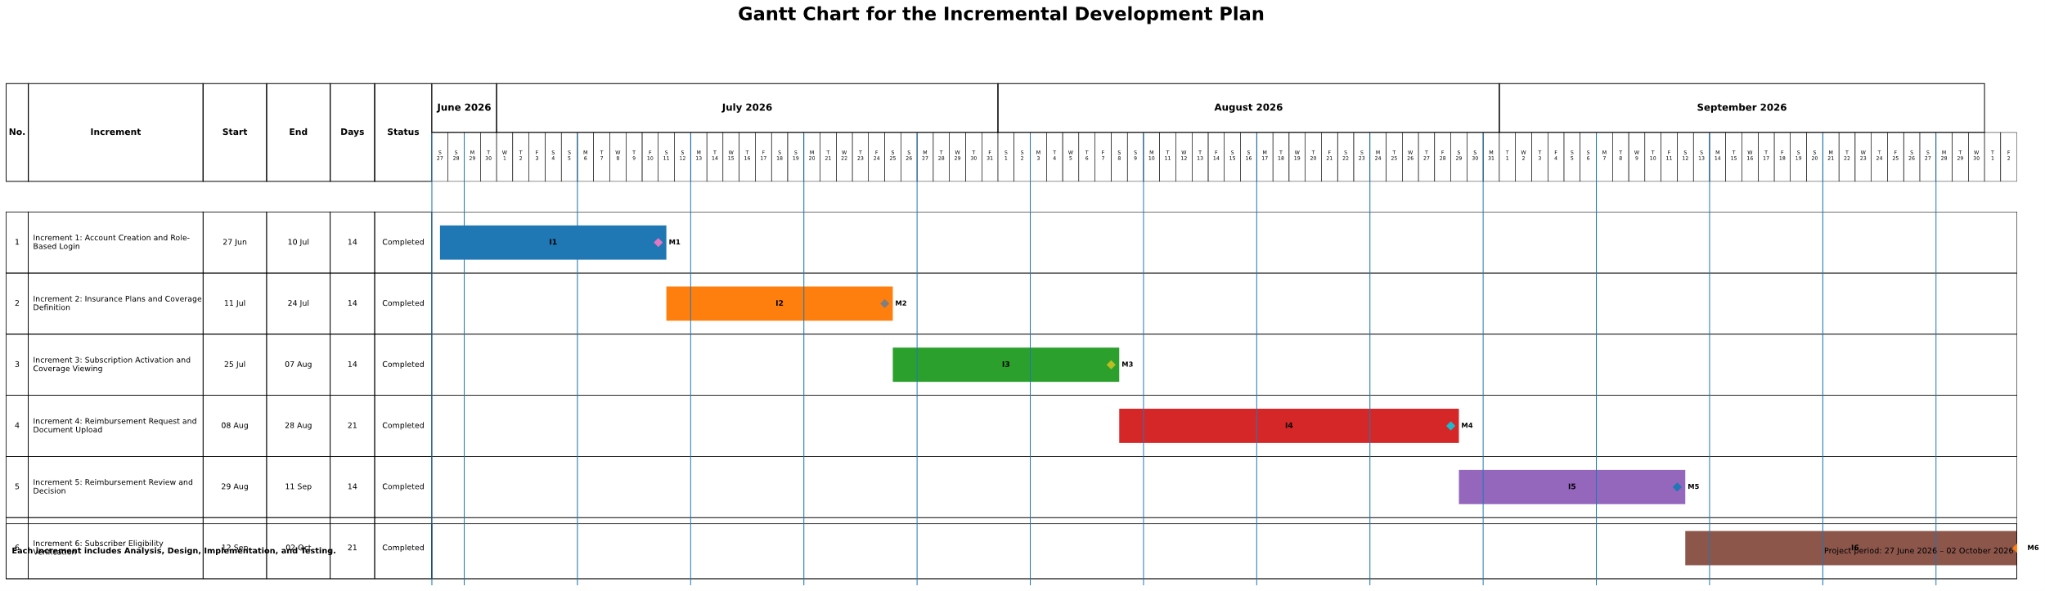
Figure 1. Gantt Chart for the Incremental Development Plan

The project schedule was organized according to the Incremental Development Methodology over a period of fourteen weeks, from 27 June 2026 to 2 October 2026. As illustrated in Figure 1, the project was divided into six functional increments.
The first increment focused on account creation and role-based login. The second increment covered insurance plan management and coverage definition. The third increment addressed subscription activation and coverage viewing. The fourth increment implemented reimbursement request submission and document upload, followed by reimbursement review and decision-making in the fifth increment. The sixth increment focused on subscriber eligibility verification.
Each increment involved analysis, design, implementation, and testing activities. Integration checks, documentation, and final project preparation supported the development process. This organization allowed the main system functions to be developed and evaluated progressively.

2.4 Risk Management

Risk management is an important part of project management because it helps identify possible problems that may affect the project schedule, quality, or implementation. In this project, the main risks were analyzed according to their probability and impact, and a mitigation plan was defined for each risk. Table 1 presents the main risks related to the development of the Health Insurance Management System.

Table 1. Project Risk Management

Risk | Probability | Impact | Mitigation Plan
Unclear or changing requirements | Medium | High | Review requirements regularly and update use case descriptions and UML diagrams when needed.
Limited project time | High | High | Divide the project into increments and focus first on the main functional modules.
Lack of real health insurance data | High | Medium | Use realistic sample data that represents subscribers, insurance plans, subscriptions, and reimbursement requests.
Errors in UML diagrams or system models | Medium | Medium | Review diagrams several times and ensure that they match the functional requirements.
Database design issues | Medium | High | Define entities, relationships, primary keys, and foreign keys carefully before implementation.
Integration problems between increments | Medium | High | Test each increment separately before integrating it with the other modules,
Authentication or access control errors | Medium | High | Apply role-based access control and test each user role separately.
File upload problems for invoices or medical documents | Medium | Medium | Validate file type, file size, and request ownership before saving uploaded documents.
Security and privacy risks | Medium | High | Protect user data, restrict access according to roles, and avoid exposing sensitive information.
Insufficient testing time | Medium | Medium | Prepare test cases early and test each module after its implementation.
User interface complexity | Medium | Medium | Design simple interfaces and keep the main user tasks clear and easy to perform.
Technical environment or dependency issues | Medium | Medium | Use stable development tools and keep backups of the project files and source code.

2.5 Team Roles and Task Distribution
Table 2. Team Roles and Task Distribution
Team Member | Role | Main Responsibilities
Baraa Alhayek | Frontend and Backend Developer | Implemented frontend interfaces, backend logic, database interaction, and integration between the user interface and system modules.
Abdulaziz Alhaj | Frontend Developer | Developed frontend pages, user interface components, page layouts, and supported the presentation of system functions to users.
Braa & Abdulaziz | UI/UX Designer | Designed interface structure, improved screen appearance, organized user interaction flow, and supported usability and visual consistency.

2.6 Quality Management in the Project
Quality management was considered an important part of the development process of the Health Insurance Management System. The purpose of quality management was to ensure that the system requirements were correctly implemented, the main functions worked as expected, and the final prototype was clear, reliable, and suitable for the project scope. Several quality assurance practices were followed during the project. First, the functional requirements were reviewed and compared with the system models, including use case descriptions, activity diagrams, and sequence diagrams. This helped ensure that the analysis and design models were consistent with the actual system functions. Second, code review was applied during the implementation phase. The source code was reviewed to improve readability, reduce unnecessary repetition, and ensure that the main modules were implemented according to their intended responsibilities. This was especially important for modules such as authentication, insurance plan management, subscription activation, reimbursement request processing, and eligibility verification. Third, each increment was tested after implementation. Since the project follows the Incremental Development Methodology, every functional module was checked before moving to the next increment. This helped detect errors early and reduced the risk of integration problems between modules. Acceptance criteria were also used to evaluate whether a feature was complete. For example, the authentication module was considered acceptable only if each user could log in and access the functions related to his or her role. Similarly, the reimbursement request module was considered acceptable only if the subscriber could submit a request, upload supporting documents, and track the request status. In addition, usability and interface consistency were considered during the development process. The system interfaces were reviewed to ensure that the main tasks were clear and easy to perform for subscribers, system administrators, and medical service providers. Therefore, quality management in this project was achieved through requirement review, code review, incremental testing, acceptance criteria, and usability review. These practices helped improve the reliability, clarity, and overall quality of the Health Insurance Management System.

2.7 Project Management Tools Used
Several tools were used to support the development and documentation of the Health Insurance Management System.
Git and GitHub were used for version control, tracking source code changes, and maintaining the project repository. Microsoft Word was used to prepare the project report, while Microsoft PowerPoint was used to create the final presentation.
UML diagrams, including use case, activity, sequence, and class diagrams, were used to represent system requirements and workflows. Additionally, a Gantt chart was used to organize the project schedule into six functional increments and monitor development progress.
These tools supported project organization, documentation, and source code management throughout the development process.

2.8 Monitoring and Continuous Evaluation Mechanisms
Monitoring and continuous evaluation were used during the development of the Health Insurance Management System to ensure that the project was progressing according to the planned schedule and objectives. Since the project followed the Incremental Development Methodology, it was important to review each increment before moving to the next one. The progress of the project was monitored through regular reviews of the completed tasks and remaining tasks. The project schedule was compared with the actual progress in order to identify any delay or missing work. The Gantt chart was used as a reference to follow the main phases of the project, including requirement analysis, system modeling, design, implementation, testing, and final delivery. Continuous evaluation was also applied through reviewing the system requirements, UML diagrams, and implemented modules. When an error or inconsistency was found, the related part was corrected before continuing with the next development stage. This helped improve the quality and consistency of the system. In addition, feedback from the supervisor was considered during the project development process. The comments and suggestions received during reviews helped improve the requirements, diagrams, report structure, and presentation of the system. This ensured that the project remained aligned with the academic requirements and the defined project scope. Each functional increment was also evaluated after implementation. The authentication module, insurance plan management module, subscription management module, reimbursement request module, review workflow, and eligibility verification module were checked separately before integration. This made it easier to detect problems early and reduce integration errors. Overall, monitoring and continuous evaluation helped the team control the project progress, improve the quality of the deliverables, and ensure that the main objectives of the Health Insurance Management System were achieved gradually and systematically.

2.9 Software Configuration Management (SCM)
Software Configuration Management was used to organize the source code and manage changes during the development of the Health Insurance Management System. The purpose of SCM was to keep the project files controlled, track modifications, and reduce the risk of losing or overwriting important parts of the system. It was used as a version control tool to track changes in the project source code, while GitHub was used as a remote repository to store and manage the project online. The first version of the project was uploaded to GitHub as the initial project version. After that, important modifications were saved using commits with descriptive messages and then pushed to GitHub to keep the remote repository updated. This workflow helped document the development history of the project. Each commit represented a specific change or improvement, such as updating a module, fixing an error, improving the user interface, or modifying system functionality. This made it easier to understand what changes were made during the development process. Important project versions were preserved after completing major milestones, such as finishing the analysis models, completing a system module, or preparing a stable version for testing. This helped maintain better control over the project files and supported the incremental development process. Overall, the use of Git and GitHub supported source code organization, change tracking, backup management, and version control. This approach was suitable for the project because it helped keep the development process organized and reduced the risk of losing important project files.

Chapter 3: Theoretical Framework and Previous Studies

3.1 Introduction
This chapter presents the theoretical framework and previous studies related to the Health Insurance Management System. It introduces the main concepts related to health insurance management and digital health information systems. It also reviews similar systems and related studies that address health data management, reimbursement requests, eligibility verification, and administrative workflow automation. The chapter also includes a comparative analysis of existing systems in order to identify their main features, strengths, and limitations. Based on this analysis, the research gap that the proposed system aims to address is identified. In addition, the chapter presents relevant modern technologies and concepts that support the development of health information management systems. This chapter provides the theoretical and technical foundation for the project. It shows how the proposed system builds on previous work and existing solutions while providing an organized software model suitable for managing health insurance processes.

3.2 Previous Studies in Similar and Intelligent Systems
This section reviews selected previous studies and similar systems related to health insurance management, digital claims processing, reimbursement workflows, eligibility verification, and digital transformation in health information systems. The purpose is to identify the main contributions, approaches, and limitations of previous work. The selected studies are related to the main functions of the proposed Health Insurance Management System, such as managing insurance data, processing reimbursement requests, verifying eligibility, and improving administrative workflows.

3.2.1 Digital Health Insurance Management Systems
Okumu et al. (2022) reviewed the role of digital health insurance management systems in scaling health insurance coverage in low- and middle-income countries, using Nigeria as a case study. The study showed that digital insurance management systems can support enrollment, insurance administration, and access to health insurance services. It also highlighted the importance of ease of use, digital infrastructure, trust, data protection, and stakeholder training. However, the study mainly focused on expanding insurance coverage and improving adoption of digital insurance schemes. It did not present a complete software model that combines insurance plan management, subscription activation, reimbursement requests, document upload, request review, and eligibility verification in one integrated system.

3.2.2 Digital Claims Processing
dzakpah and Duomo (2023) studied the impact of digital health technology on health insurance claims rejection rates in Ghana. The study compared paper-based claims processing with digital claims processing and found that digital systems can help reduce denied claims and lower the cost of claim rejection. This shows the importance of using digital tools to improve accuracy and efficiency in health insurance claims management. The limitation of this study is that it focused mainly on claims rejection and did not cover the full administrative workflow of a health insurance management system. It did not include modules such as subscriber subscription management, insurance plan management, coverage rules, document upload, and provider eligibility verification.

3.2.3 Digital Claims Management in Health Financing
The World Health Organization (2023) analyzed digital claims management in Estonia’s health insurance system. The report explained how digital claims management supports the submission and processing of claims between healthcare providers and the health insurance fund. It also showed that claims data can be used for several purposes, including payment processing, monitoring, and strategic healthcare purchasing. However, this report focused on a national health insurance system with advanced health financing mechanisms. It did not present a small-scale academic software prototype that can be used to manage the basic workflows of a health insurance management system, such as subscriptions, reimbursement requests, document upload, and eligibility verification.

3.2.4 Digital Technologies in Government-Supported Health Insurance
The Asian Development Bank (2021) discussed how digital technologies can support government-supported health insurance systems in Asia and the Pacific. The report emphasized the role of digital solutions in supporting the core business processes of public health insurance operators, improving efficiency, managing data, and supporting service delivery. The limitation of this report is that it provides a broad regional and policy-oriented overview. It does not focus on the detailed design or implementation of a specific health insurance management application. Therefore, it is useful as a general reference, but it does not provide a complete software design for the system proposed in this project.

3.2.5 Health Insurance Claims Management Challenges
Verulava (2025) analyzed claims adjustment processes in Georgia’s health insurance sector using a qualitative study supported by claims data. The study focused on operational challenges affecting health insurance claims management, especially the adjustment and reimbursement processes between insurers and healthcare providers. It identified several problems, including incomplete medical documentation, weak coordination between insurers and providers, administrative inefficiency, and reliance on manual procedures. The study is relevant to this project because it highlights the importance of organizing reimbursement requests, improving document management, and supporting clearer communication between the actors involved in health insurance workflows. These issues are directly related to the proposed Health Insurance Management System, which includes reimbursement request submission, medical document upload, request review, and eligibility verification. However, the study focused mainly on analyzing claims adjustment challenges in a specific insurance context. It did not present a complete software prototype that combines insurance plan management, subscription activation, reimbursement request processing, document upload, approval or rejection workflow, and eligibility verification in one integrated system.

3.3 Modern Technologies and Frameworks in the Field
Modern health insurance management systems depend on several software technologies that support data organization, secure access, workflow automation, and communication between users. These technologies help transform traditional administrative processes into digital services that are easier to manage, monitor, and improve. Web application technologies are commonly used to build systems that can be accessed by different types of users through a browser. In a health insurance management system, the frontend layer provides the user interfaces for subscribers, system administrators, and medical service providers. These interfaces allow users to perform tasks such as viewing subscription details, submitting reimbursement requests, uploading documents, reviewing requests, and verifying eligibility. Backend technologies are used to implement the business logic of the system. They handle operations such as user authentication, insurance plan management, subscription activation, reimbursement request processing, document validation, and eligibility checking. The backend also connects the user interface with the database and ensures that each operation follows the system rules. Database management systems are essential in health insurance applications because they store and organize important data. This includes user accounts, insurance plans, covered services, subscriptions, reimbursement requests, uploaded documents, and request statuses. A structured database helps maintain data consistency and supports accurate retrieval of information when needed. Role-Based Access Control is also an important concept in this field. It ensures that each user can access only the functions related to his or her role. For example, subscribers can submit reimbursement requests, system administrators can manage plans and review requests, and medical service providers can verify eligibility. This improves system security and prevents unauthorized access to sensitive data. Document management and file upload technologies are also required because reimbursement requests usually depend on supporting files, such as invoices or medical documents. The system should validate uploaded files, store document information, and link each document to the correct reimbursement request. In addition, API communication can be used to connect the frontend and backend parts of the system. APIs allow the system to exchange data between interfaces and server-side logic in a structured way. This makes the system easier to maintain and extend in the future. Overall, modern technologies and frameworks support the development of secure, organized, and scalable health insurance management systems. They help improve administrative efficiency, reduce manual work, and provide clearer interaction between subscribers, administrators, and medical service providers.

3.4 Comparative Analysis of Existing Systems and Products
This section compares three types of existing systems related to health insurance management: hospital insurance and billing modules, digital health insurance platforms, and claims management systems. The comparison aims to identify their main functions, strengths, and limitations, and to clarify how the proposed Health Insurance Management System provides a simplified and integrated academic model.
Table 3. Comparative Analysis of Existing Systems and Products
System / Product | Main Functions | Strengths | Limitations | Relation to System
Hospital Insurance/Billing Modules | Patient billing, insurance claims, payment records, and policy handling. | Useful for connecting hospital billing with insurance procedures. | Focused mainly on provider-side operations. They do not provide a full subscriber-centered workflow. | The proposed system includes subscribers, administrators, and medical service providers in one workflow.
Digital Health Insurance Platforms | Policy access, claim submission, document upload, and claim tracking. | Convenient for subscribers and reduces manual communication. | Usually limited to one insurance company and may not show internal administrative workflows. | The proposed system combines subscriber services with administrator functions and provider eligibility verification.
Claims Management Systems | Claims processing, coverage calculation, eligibility checking, and claim decision support. | Strong in automating and controlling claims workflows. | Often complex and designed for large insurance organizations. | The proposed system focuses on the essential workflow in a simplified academic prototype.

3.5 Research Gap and Proposed Innovation
Based on the reviewed studies and the comparative analysis of existing systems, it can be observed that many current solutions focus on specific parts of health insurance operations. Hospital insurance and billing modules mainly focus on provider-side billing and insurance-related procedures. Digital health insurance platforms usually focus on subscriber services, such as viewing policy information, submitting claims, uploading documents, and tracking claim status. Claims management systems are more specialized in processing and controlling claims workflows, but they are often designed for large insurance organizations. The main gap identified is the lack of a simplified and integrated academic software model that combines the essential health insurance management functions in one platform. Existing systems may support some of these functions, but they often do not clearly combine insurance plan management, coverage definition, subscription activation, reimbursement request submission, document upload, request review, approval or rejection, status tracking, and eligibility verification within one structured workflow. The proposed Health Insurance Management System aims to address this gap by providing a practical software prototype that integrates the main actors and processes of health insurance management. The system supports three main actors: the subscriber, the system administrator, and the medical service provider. Each actor has specific functions according to his or her role, which helps organize responsibilities and improve access control. The proposed innovation of this project is not based on a new algorithm, but on providing a different applied software model that combines the main administrative operations of health insurance management in a clear and organized way. The system connects subscriptions, insurance plans, reimbursement requests, uploaded documents, request decisions, and eligibility verification in one platform. Therefore, the project contributes by presenting a simplified, role-based, and integrated health insurance management system that is suitable for academic implementation and can be extended in the future to include more advanced services, such as online payment, external system integration, or automated decision support.

3.6 Theoretical Framework and Reference Studies
The proposed Health Insurance Management System is based on several theoretical and technical concepts related to software engineering, health insurance administration, and information system design. These concepts provide the foundation for understanding how the system is structured and how its main functions are organized. One of the main concepts used in this project is health insurance management. Health insurance management involves organizing insurance plans, covered services, subscriptions, reimbursement requests, and eligibility verification. In the proposed system, these concepts are represented as connected processes that allow subscribers, system administrators, and medical service providers to interact through a structured digital platform. Another important concept is workflow automation. Workflow automation refers to transforming manual administrative procedures into organized digital steps. In this project, reimbursement request submission, document upload, request review, approval or rejection, and status tracking are organized as a workflow. This helps reduce manual effort and improves clarity in the processing of reimbursement requests. Role-Based Access Control is also an important theoretical concept in the system design. It ensures that each user can access only the functions related to his or her role. For example, subscribers can submit and track reimbursement requests, system administrators can manage insurance plans and review requests, and medical service providers can verify subscriber eligibility. This concept supports system security and helps organize responsibilities among users. The project also depends on database design principles. The system requires a structured database to store users, insurance plans, covered services, subscriptions, reimbursement requests, uploaded documents, and request statuses. Proper database design helps maintain data consistency and supports accurate retrieval of information. In addition, document management is an important concept in the proposed system. Medical reimbursement requests usually require supporting documents such as invoices or medical reports. Therefore, the system must organize uploaded documents and link them to the correct reimbursement request. Overall, the theoretical framework of this project combines health insurance management concepts, workflow automation, role-based access control, database design, and document management. These concepts support the design and implementation of an organized and secure Health Insurance Management System.

3.7 Current and Future Trends in the Field
Current trends in health insurance management are strongly related to digital transformation and the automation of administrative workflows. Many health insurance processes are moving from manual and paper-based procedures to digital platforms that support faster access to information, better organization of data, and improved communication between subscribers, administrators, and healthcare providers. One important trend is the digital management of claims and reimbursement requests. Digital systems allow subscribers to submit requests online, upload supporting medical documents, and track request status. This reduces the need for manual communication and helps make the reimbursement process clearer and more organized. Another important trend is electronic eligibility verification. Instead of checking subscription status manually, medical service providers can use digital systems to verify whether a subscriber has an active and valid insurance subscription before providing covered medical services. This can reduce delays and improve the accuracy of healthcare service procedures. Future health insurance systems may also include more advanced services, such as online payment, integration with external healthcare systems, automated notifications, and decision-support tools. These features can improve the efficiency of insurance operations and provide better services to users. Future versions of the system may also include an intelligent chatbot to support users and improve interaction with the platform. The chatbot could help subscribers understand insurance coverage, learn how to submit reimbursement requests, identify the required medical documents, and receive general guidance about the system workflow. It could also provide quick answers to frequently asked questions related to subscriptions, request status, and eligibility verification. The chatbot would not replace the system administrator, but it could reduce repetitive inquiries and improve the user experience. This future feature would make the Health Insurance Management System more interactive, accessible, and easier to use. In the future, intelligent technologies such as machine learning may also be used to support claim analysis, fraud detection, risk evaluation, and recommendation of suitable insurance plans. However, the proposed project focuses on the core administrative workflow of health insurance management and can be extended later to include such advanced features. Overall, the current and future trends in the field show the importance of building secure, organized, and scalable digital health insurance systems. These trends support the relevance of the proposed Health Insurance Management System and show that it can be developed further in future work.

Chapter 4: Requirements Analysis and System Modeling

4.1 Introduction
This chapter presents the requirements analysis and system modeling of the Health Insurance Management System. It identifies the main actors who interact with the system and defines the functional and non-functional requirements needed to achieve the project objectives. The chapter also presents the system modeling using Unified Modeling Language diagrams, including the use case diagram, use case descriptions, activity diagrams, sequence diagrams, and class diagram. These models help clarify the system functions, user interactions, and main workflows before moving to the design and implementation phases.

4.2 Feasibility Study
A feasibility study was conducted to evaluate whether the proposed Health Insurance Management System can be developed and used successfully. The study focuses on three main aspects: technical feasibility, economic feasibility, and operational feasibility.

4.2.1 Technical Feasibility
The system is technically feasible because it can be developed using available software development tools and common web technologies. The required functions, such as user authentication, insurance plan management, subscription activation, reimbursement request submission, document upload, request review, and eligibility verification, can be implemented using a structured database and a web-based application.
The project does not require complex hardware or advanced infrastructure. It can be developed and tested on standard computers using a local development environment. Therefore, from a technical point of view, the system can be implemented within the available resources and project scope.

4.2.2 Economic Feasibility
The system is economically feasible because it can be developed as an academic prototype using available and low-cost development tools. The project does not require expensive equipment, paid services, or large infrastructure. Most of the required resources are related to development time, analysis, design, implementation, and testing.
In addition, the proposed system can reduce manual administrative work by organizing insurance plans, subscriptions, reimbursement requests, and eligibility verification in a digital platform. This makes the project valuable from an economic perspective, especially because it aims to improve organization and reduce time spent on repetitive procedures.

4.2.3 Operational Feasibility
The system is operationally feasible because its functions are based on real health insurance workflows that can be understood by the main users. The system supports three main actors: the subscriber, the system administrator, and the medical service provider. Each actor has clear responsibilities and access to specific functions according to his or her role.
The proposed system is designed to simplify daily operations such as viewing coverage details, submitting reimbursement requests, reviewing requests, and checking subscriber eligibility. Therefore, the system can be used effectively if users receive basic guidance on how to interact with the platform.

4.3 Requirements Collection
Requirements collection is an important step in the analysis phase because it helps define what the system should provide and how users are expected to interact with it. In this project, the requirements of the Health Insurance Management System were collected through several sources related to the project domain and system objectives. The main sources of requirements included analyzing the health insurance management process, reviewing similar digital insurance systems, studying the needs of the expected users, and discussing the project scope with the development team and supervisor. These sources helped identify the main functions required in the system, such as role-based authentication, insurance plan management, subscription activation, reimbursement request submission, document upload, request review, and eligibility verification. The collected requirements were then organized into functional and non-functional requirements. Functional requirements describe the services and operations that the system should perform, while non-functional requirements describe quality aspects such as security, usability, reliability, maintainability, and performance. This process helped ensure that the system requirements were clear, realistic, and aligned with the objectives of the project.

4.4 Stakeholders Identification and Needs Analysis
This section identifies the main stakeholders of the Health Insurance Management System and summarizes their needs. Understanding these stakeholders helps define the system functions and organize user responsibilities clearly.
Table 4. Stakeholders and Their Needs
Stakeholder | Main Needs
Subscriber | View subscription details, coverage, submit reimbursement requests, upload documents, and track request status.
System Administrator | Manage insurance plans, covered services, subscriptions, and review reimbursement requests.
Medical Service Provider | Check subscriber eligibility and verify active and valid subscription status.

As shown in Table 4, each stakeholder has specific needs that are reflected in the functional requirements of the system.

4.5 Functional Requirements
Functional requirements describe the main services and operations that the system must provide to its users. In the Health Insurance Management System, these requirements are defined according to the needs of the main stakeholders: the subscriber, the system administrator, and the medical service provider.
FR-01: The system shall allow the subscriber to create a new subscriber account.
FR-02: The system shall allow the medical service provider to create a new medical service provider account.
FR-03: The system shall allow all actors to log in to the system according to their assigned roles.
FR-04: The system shall allow the system administrator to add a new health insurance plan. FR-05: The system shall allow the system administrator to define covered medical services and their coverage percentages within the insurance plan.
FR-06: The system shall allow the system administrator to activate a subscriber’s subscription in a health insurance plan.
FR-07: The system shall allow the subscriber to view subscription details and health coverage information.
FR-08: The system shall allow the subscriber to submit a new medical reimbursement request. FR-09: The system shall allow the subscriber to upload an invoice or medical document with the reimbursement request.
FR-10: The system shall allow the subscriber to track the status of the medical reimbursement request.
FR-11: The system shall allow the system administrator to review medical reimbursement requests.
FR-12: The system shall allow the system administrator to approve a medical reimbursement request.
FR-13: The system shall allow the system administrator to reject a medical reimbursement request with a rejection reason.
FR-14: The system shall allow the medical service provider to verify the subscriber’s eligibility and subscription status.
FR-15: The system shall allow all actors to securely log out of the system.

4.6 Non-Functional Requirements
Non-functional requirements describe the quality characteristics that the system should satisfy. These requirements do not define specific system functions, but they describe how the system should perform in terms of performance, security, usability, reliability, and maintainability. Table 5 presents the main non-functional requirements of the Health Insurance Management System in a measurable way.
Table 5. Non-Functional Requirements
Code | Category | Non-Functional Requirement | Measurable Criterion
NFR-01 | Performance | The system shall display the main pages within an acceptable response time. | Main pages should load within 3 seconds under normal usage conditions.
NFR-02 | Performance | The system shall process common operations such as login, viewing subscription details, and tracking request status efficiently. | Common operations should be completed within 3 seconds under normal usage conditions.
NFR-03 | Security | The system shall protect user accounts and prevent unauthorized access. | Only registered users with valid email and password should be able to access protected system functions.
NFR-04 | Security | The system shall restrict access according to the user role. | Subscribers, system administrators, and medical service providers should only access functions related to their assigned roles.
NFR-05 | Usability | The system shall provide clear and simple interfaces for the main users. | Users should be able to access their main functions within 3 to 5 clear steps.
NFR-06 | Reliability | The system shall reduce data entry errors through validation. | Required fields should be checked before account creation, subscription activation, and reimbursement request submission.

4.7 Requirement Prioritization
Requirement prioritization helps organize the system requirements according to their importance and impact on the project objectives. In this project, the functional requirements were prioritized based on their necessity for the basic operation of the Health Insurance Management System. The prioritization was done using simple priority levels. “Must Have” requirements represent essential functions that are required for the system to work correctly. “Should Have” requirements represent important functions that improve the system workflow and user experience.

Table 6. Functional Requirements Prioritization
Code | Actor | Priority | Reason
FR-01 | Subscriber | Must Have | Needed to create a subscriber account.
FR-02 | Medical Service Provider | Must Have | Needed to create a provider account.
FR-03 | All Actors | Must Have | Needed for role-based login.
FR-04 | System Administrator | Must Have | Needed to add insurance plans.
FR-05 | System Administrator | Must Have | Needed to define covered services and coverage percentages.
FR-06 | System Administrator | Must Have | Needed to activate subscriber subscriptions.
FR-07 | Subscriber | Should Have | Helps subscribers view subscription and coverage details.
FR-08 | Subscriber | Must Have | Needed to submit reimbursement requests.
FR-09 | Subscriber | Must Have | Needed to upload invoices or medical documents.
FR-10 | Subscriber | Should Have | Helps subscribers track reimbursement request status.
FR-11 | System Administrator | Must Have | Needed to review reimbursement requests.
FR-12 | System Administrator | Must Have | Needed to approve valid reimbursement requests.
FR-13 | System Administrator | Must Have | Needed to reject requests with a clear reason.
FR-14 | Medical Service Provider | Must Have | Needed to verify subscriber eligibility and subscription status.

4.8 UML Diagrams for Requirements
UML diagrams are used to model the main requirements of the Health Insurance Management System in a clear and structured way. These diagrams help represent the interaction between system actors and system functions, as well as the main workflows of the proposed system. In this project, the UML modeling includes a use case diagram, use case descriptions, activity diagrams, and sequence diagrams. The use case diagram provides a general view of the main system functions, while the activity and sequence diagrams describe the behavior and interaction flow of important operations.

4.8.1 Use Case Diagram
The use case diagram represents the main interactions between the actors and the Health Insurance System. It shows the main functions performed by the subscriber, the system administrator, and the medical service provider. Authentication is considered a prerequisite for accessing system services according to each actor’s role.
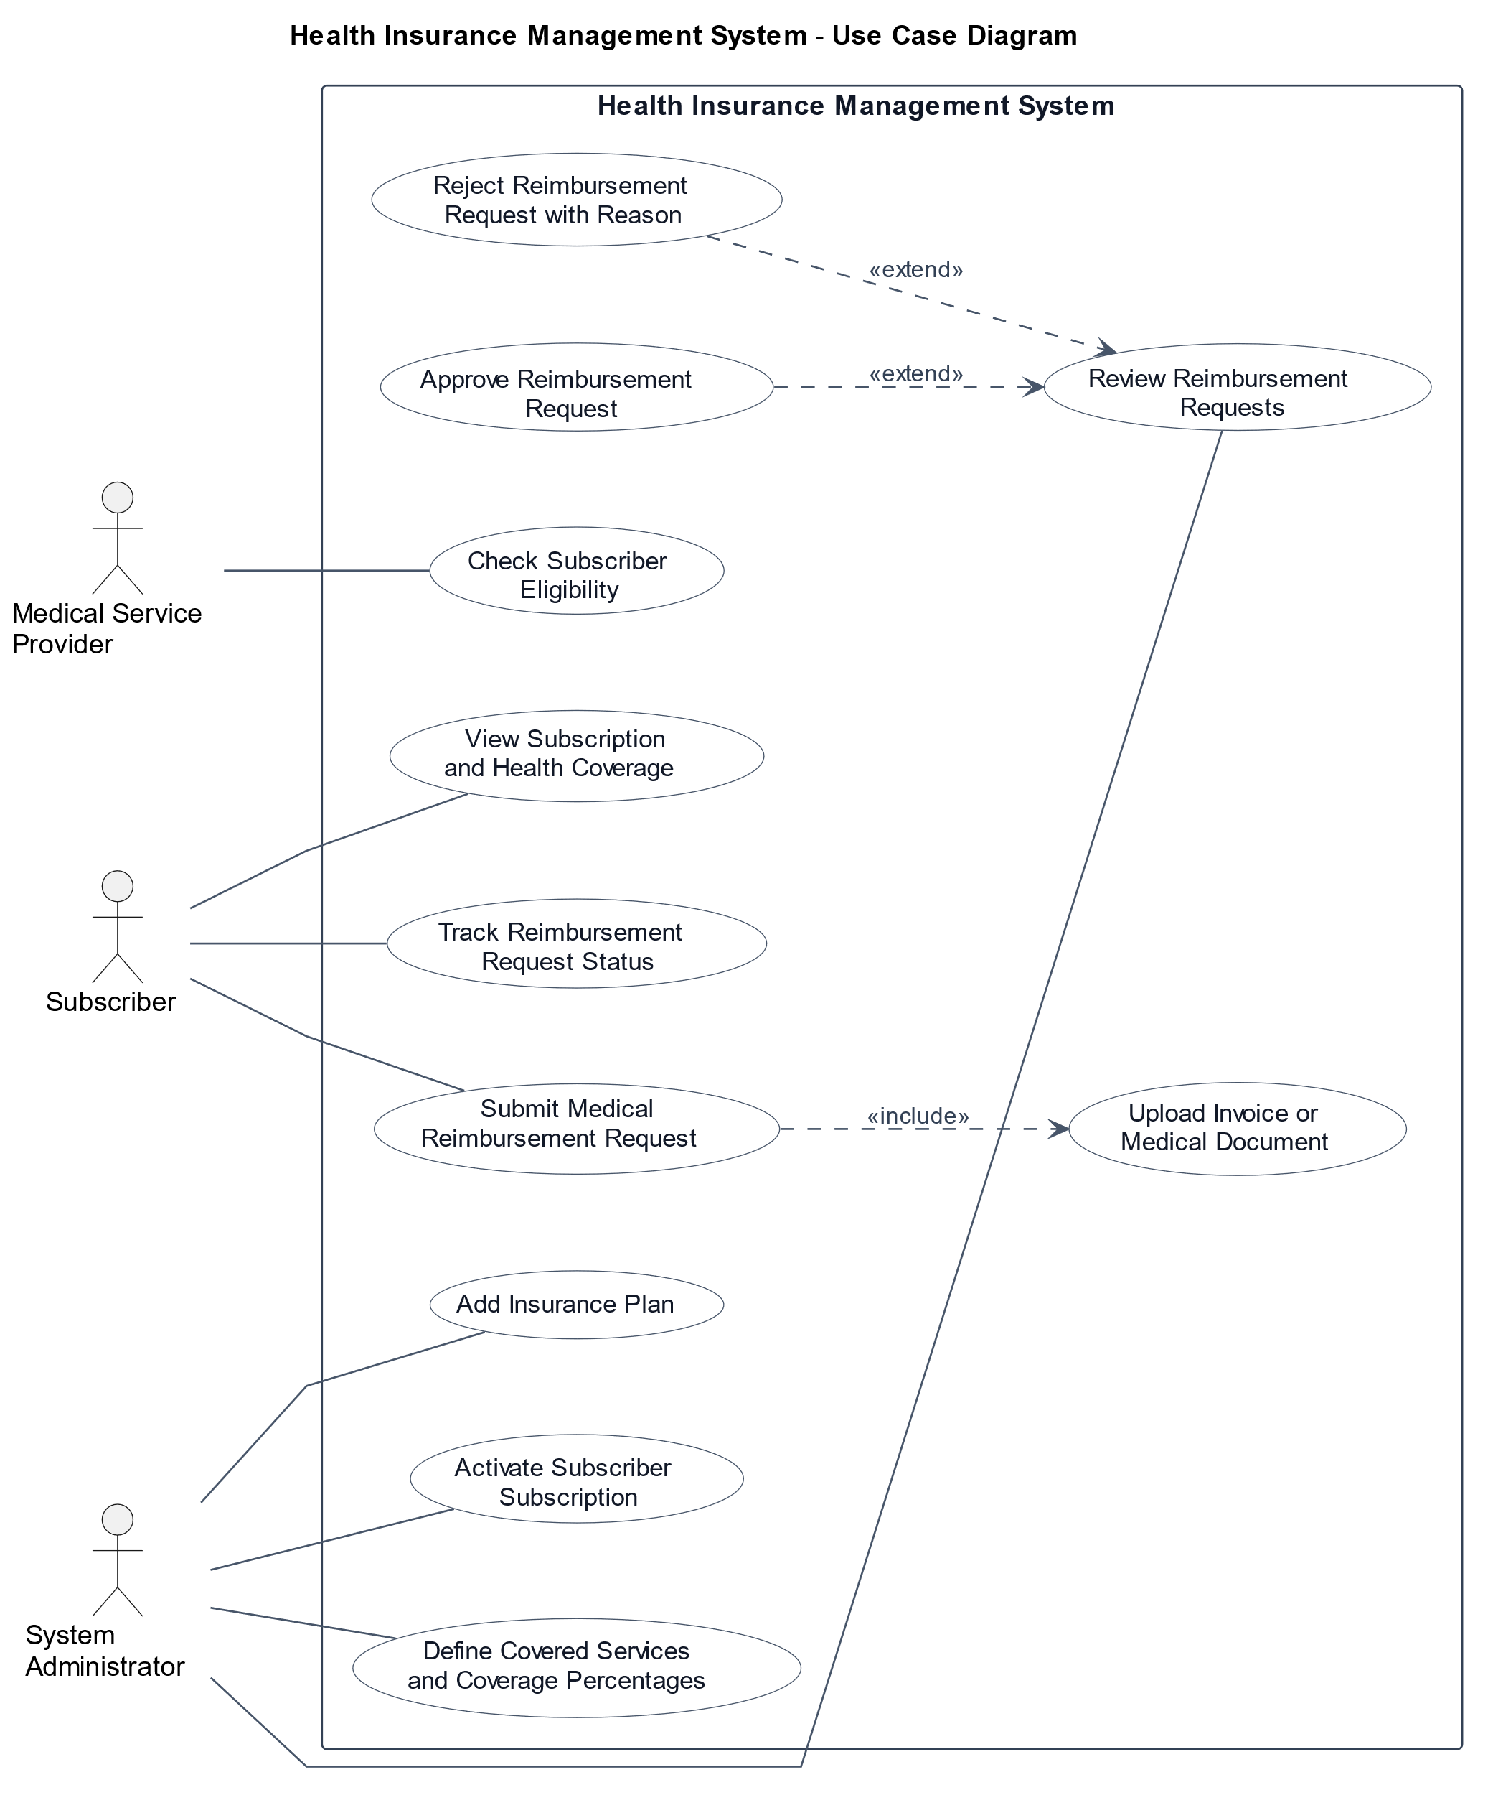
Figure 2. Use Case Diagram of the Health Insurance System
As shown in Figure 2, each actor interacts with specific system functions according to his or her role. This supports role-based access and helps organize the main system responsibilities.

4.8.2 Use Case Descriptions
Use case descriptions provide a textual explanation of the main interactions between the system actors and the Health Insurance System. They help clarify the goal of each use case, the responsible actor, and the related functional requirements

Table 7. Use Case Description: Create New Account
Item | Content
Use Case Name | Create New Account
Actors | Subscriber
Case Description | The subscriber creates a new account by entering the required personal information.
Preconditions | The subscriber is not registered in the system.
Postconditions | A new subscriber account is created successfully, and the subscriber can log in.
Main Flow | 1. The subscriber opens the registration page. 2. The subscriber enters the required personal information. 3. The subscriber submits the registration form. 4. The system validates the entered data. 5. The system creates a new subscriber account.
Exceptional Flow | Invalid data, an already existing email, weak password, or server error.

Table 8. Use Case Description: Create Medical Service Provider Account
Item | Content
Use Case Name | Create Medical Service Provider Account
Actors | Medical Service Provider
Case Description | The medical service provider creates an account by entering official facility information, including the license number.
Preconditions | The medical service provider is not registered in the system and has valid official facility information.
Postconditions | A new medical service provider account is created successfully, and the provider can log in and access the system.
Main Flow | 1. The medical service provider opens the registration page. 2. The provider enters the required facility information. 3. The provider submits the registration form. 4. The system validates the entered data. 5. The system creates a new medical service provider account.
Exceptional Flow | Invalid data, an already existing email, invalid license number, weak password, or server error.

Table 9. Use Case Description: Role-Based Login
Item | Content
Use Case Name | Role-Based Login
Actors | Subscriber / Medical Service Provider / System Administrator
Case Description | The user logs in using email and password, and the system grants access according to the user role.
Preconditions | The user has an existing account in the system.
Postconditions | The user is authenticated and redirected to the correct dashboard according to the user role.
Main Flow | 1. The user opens the login page. 2. The user enters email and password. 3. The user clicks the sign-in button and submits the form. 4. The system validates the login information and identifies the user role. 5. The system grants access to the appropriate dashboard.
Exceptional Flow | Wrong email or password, inactive account, unverified account, or server error.

Table 10. Use Case Description: Add New Health Insurance Plan
Item | Content
Use Case Name | Add New Health Insurance Plan
Actors | System Administrator
Case Description | The system administrator adds a new health insurance plan by entering plan details such as name, description, coverage limits, and pricing.
Preconditions | The system administrator is logged in, and the required plan information is available.
Postconditions | A new health insurance plan is created and becomes available for subscription.
Main Flow | 1. The system administrator opens the Add Health Insurance Plan page. 2. The administrator enters the required plan details, such as name, description, coverage limits, and price. 3. The administrator submits the form. 4. The system validates the entered data. 5. The system creates the new health insurance plan.
Exceptional Flow | Missing or invalid data, duplicate plan name, or server error.

Table 11. Use Case Description: Define Covered Services and Coverage Percentages
Item | Content
Use Case Name | Define Covered Services and Coverage Percentages
Actors | System Administrator
Case Description | The system administrator selects a health insurance plan and defines the medical services covered within it, along with the coverage percentage for each service.
Preconditions | The system administrator is logged in, the health insurance plan already exists, and the list of medical services is available.
Postconditions | The selected health insurance plan is updated with covered medical services and their coverage percentages.
Main Flow | 1. The system administrator opens the health insurance plan details page. 2. The administrator selects Add Covered Services. 3. The administrator chooses medical services from the available list. 4. The administrator assigns a coverage percentage for each service. 5. The administrator submits the form. 6. The system validates and saves the coverage rules.
Exceptional Flow | Missing or invalid data, invalid coverage percentage, unavailable medical service, or server error.
Table 12. Use Case Description: Activate Subscriber Subscription
Item | Content
Use Case Name | Activate Subscriber Subscription
Actors | System Administrator
Case Description | The system administrator activates a subscriber’s subscription in a health insurance plan.
Preconditions | The system administrator is logged in, the subscriber exists, and the health insurance plan is available.
Postconditions | The subscriber’s subscription becomes active and usable.
Main Flow | 1. The system administrator selects a subscriber. 2. The administrator selects a health insurance plan. 3. The administrator enters the subscription start and end dates. 4. The administrator confirms the activation. 5. The system creates an active subscription.
Exceptional Flow | Subscriber not found, health insurance plan not found, subscription already active, missing data, or server error.
Table 13. Use Case Description: View Subscription Details and Health Coverage
Item | Content
Use Case Name | View Subscription Details and Health Coverage
Actors | Subscriber
Case Description | The subscriber views the details of the active subscription and health coverage information.
Preconditions | The subscriber is logged in to the system.
Postconditions | The subscription details and health coverage information are displayed successfully.
Main Flow | 1. The subscriber opens the My Subscription page. 2. The system retrieves the subscriber’s active subscription data. 3. The system displays the health insurance plan details and coverage information.
Exceptional Flow | No active subscription, expired subscription, unavailable data, or server error.

Table 14. Use Case Description: Submit New Medical Reimbursement Request
Item | Content
Use Case Name | Submit New Medical Reimbursement Request
Actors | Subscriber
Case Description | The subscriber submits a new medical reimbursement request by entering service details and the paid amount.
Preconditions | The subscriber is logged in and has an active subscription.
Postconditions | A new reimbursement request is created with Pending status.
Main Flow | 1. The subscriber opens the New Reimbursement Request page. 2. The system displays the reimbursement request form. 3. The subscriber enters the service type, service date, paid amount, provider name, and description. 4. The subscriber submits the form. 5. The system validates the request data. 6. The system checks the subscriber’s active subscription and service coverage. 7. The system creates a new reimbursement request with Pending status.
Exceptional Flow | Missing or invalid data, inactive subscription, uncovered service, invalid paid amount, or server error
.
Table 15. Use Case Description: Upload Invoice or Medical Document
Item | Content
Use Case Name | Upload Invoice or Medical Document
Actors | Subscriber
Case Description | The subscriber uploads an invoice or medical document to support a reimbursement request.
Preconditions | The subscriber is logged in, and the reimbursement request exists and belongs to the subscriber.
Postconditions | The uploaded document is attached to the reimbursement request.
Main Flow | 1. The subscriber opens the reimbursement request page. 2. The subscriber selects Upload Document. 3. The subscriber chooses the invoice or medical document file. 4. The subscriber confirms the upload. 5. The system validates the file. 6. The system attaches the uploaded document to the reimbursement request.
Exceptional Flow | Invalid file type, file too large, reimbursement request not found, request not editable, upload failure, or server error.

Table 16. Use Case Description: Track Reimbursement Request Status
Item | Content
Use Case Name | Track Reimbursement Request Status
Actors | Subscriber
Case Description | The subscriber views the current status of submitted medical reimbursement requests.
Preconditions | The subscriber is logged in, and at least one reimbursement request has been submitted.
Postconditions | The reimbursement request status is displayed successfully.
Main Flow | 1. The subscriber opens the My Reimbursement Requests page. 2. The system retrieves the subscriber’s submitted requests. 3. The system displays each request with its current status: Pending, Approved, or Rejected. 4. The subscriber selects a request to view more details.
Exceptional Flow | No submitted requests, request not found, data retrieval error, or server error.

Table 17. Use Case Description: Review Reimbursement Requests
Item | Content
Use Case Name | Review Reimbursement Requests
Actors | System Administrator
Case Description | The system administrator reviews submitted medical reimbursement requests, including subscriber information, subscription details, coverage information, and uploaded documents.
Preconditions | The system administrator is logged in, and reimbursement requests exist in the system.
Postconditions | The reimbursement request details are displayed for review.
Main Flow | 1. The system administrator opens the reimbursement requests list. 2. The administrator selects a reimbursement request. 3. The system displays the request details, subscriber information, coverage information, and uploaded documents. 4. The administrator reviews the request.
Exceptional Flow | Missing documents, invalid request data, request not found, or server error.

Table 18. Use Case Description: Approve Reimbursement Request
Item | Content
Use Case Name | Approve Reimbursement Request
Actors | System Administrator
Case Description | The system administrator approves a pending reimbursement request after reviewing its documents and coverage information.
Preconditions | The system administrator is logged in, the reimbursement request exists, and its status is Pending.
Postconditions | The reimbursement request status is updated to Approved.
Main Flow | 1. The system administrator opens the reimbursement request details page. 2. The system displays the request details, coverage information, and uploaded documents. 3. The administrator reviews the request. 4. The administrator clicks Approve Request. 5. The system updates the request status to Approved and displays a success message.
Exceptional Flow | Missing documents, invalid request data, request not found, request not eligible, or server error.
Table 19. Use Case Description: Reject Reimbursement Request with Reason
Item | Content
Use Case Name | Reject Reimbursement Request with Reason
Actors | System Administrator
Case Description | The system administrator rejects a pending reimbursement request after reviewing its details and provides a clear rejection reason.
Preconditions | The system administrator is logged in, the reimbursement request exists, and its status is Pending.
Postconditions | The reimbursement request status is updated to Rejected, and the rejection reason is saved.
Main Flow | 1. The system administrator opens the reimbursement request details page. 2. The system displays the request details and uploaded documents. 3. The administrator reviews the request. 4. The administrator clicks Reject Request. 5. The administrator enters the rejection reason. 6. The system updates the request status to Rejected and saves the rejection reason.
Exceptional Flow | Missing documents, invalid request data, no rejection reason entered, request not found, or server error.

Table 20. Use Case Description: Verify Subscriber Eligibility and Status
Item | Content
Use Case Name | Verify Subscriber Eligibility and Status
Actors | Medical Service Provider
Case Description | The provider checks whether the subscriber has an active subscription and valid coverage.
Preconditions | The provider is logged in and has permission to check eligibility.
Postconditions | The eligibility status and coverage details are displayed.
Main Flow | 1. The provider opens the eligibility check page. 2. The provider enters the subscriber ID or email. 3. The provider clicks Check Eligibility. 4. The system checks the subscriber, subscription status, and coverage. 5. The system displays the eligibility result.
Exceptional Flow | Subscriber not found, inactive or expired subscription, unavailable coverage, or server error.

4.8.3 Activity Diagrams
Activity diagrams are used to represent the workflow of the most important system operations. In this project, activity diagrams are presented for the main processes that involve important decisions and interactions between actors and the system.
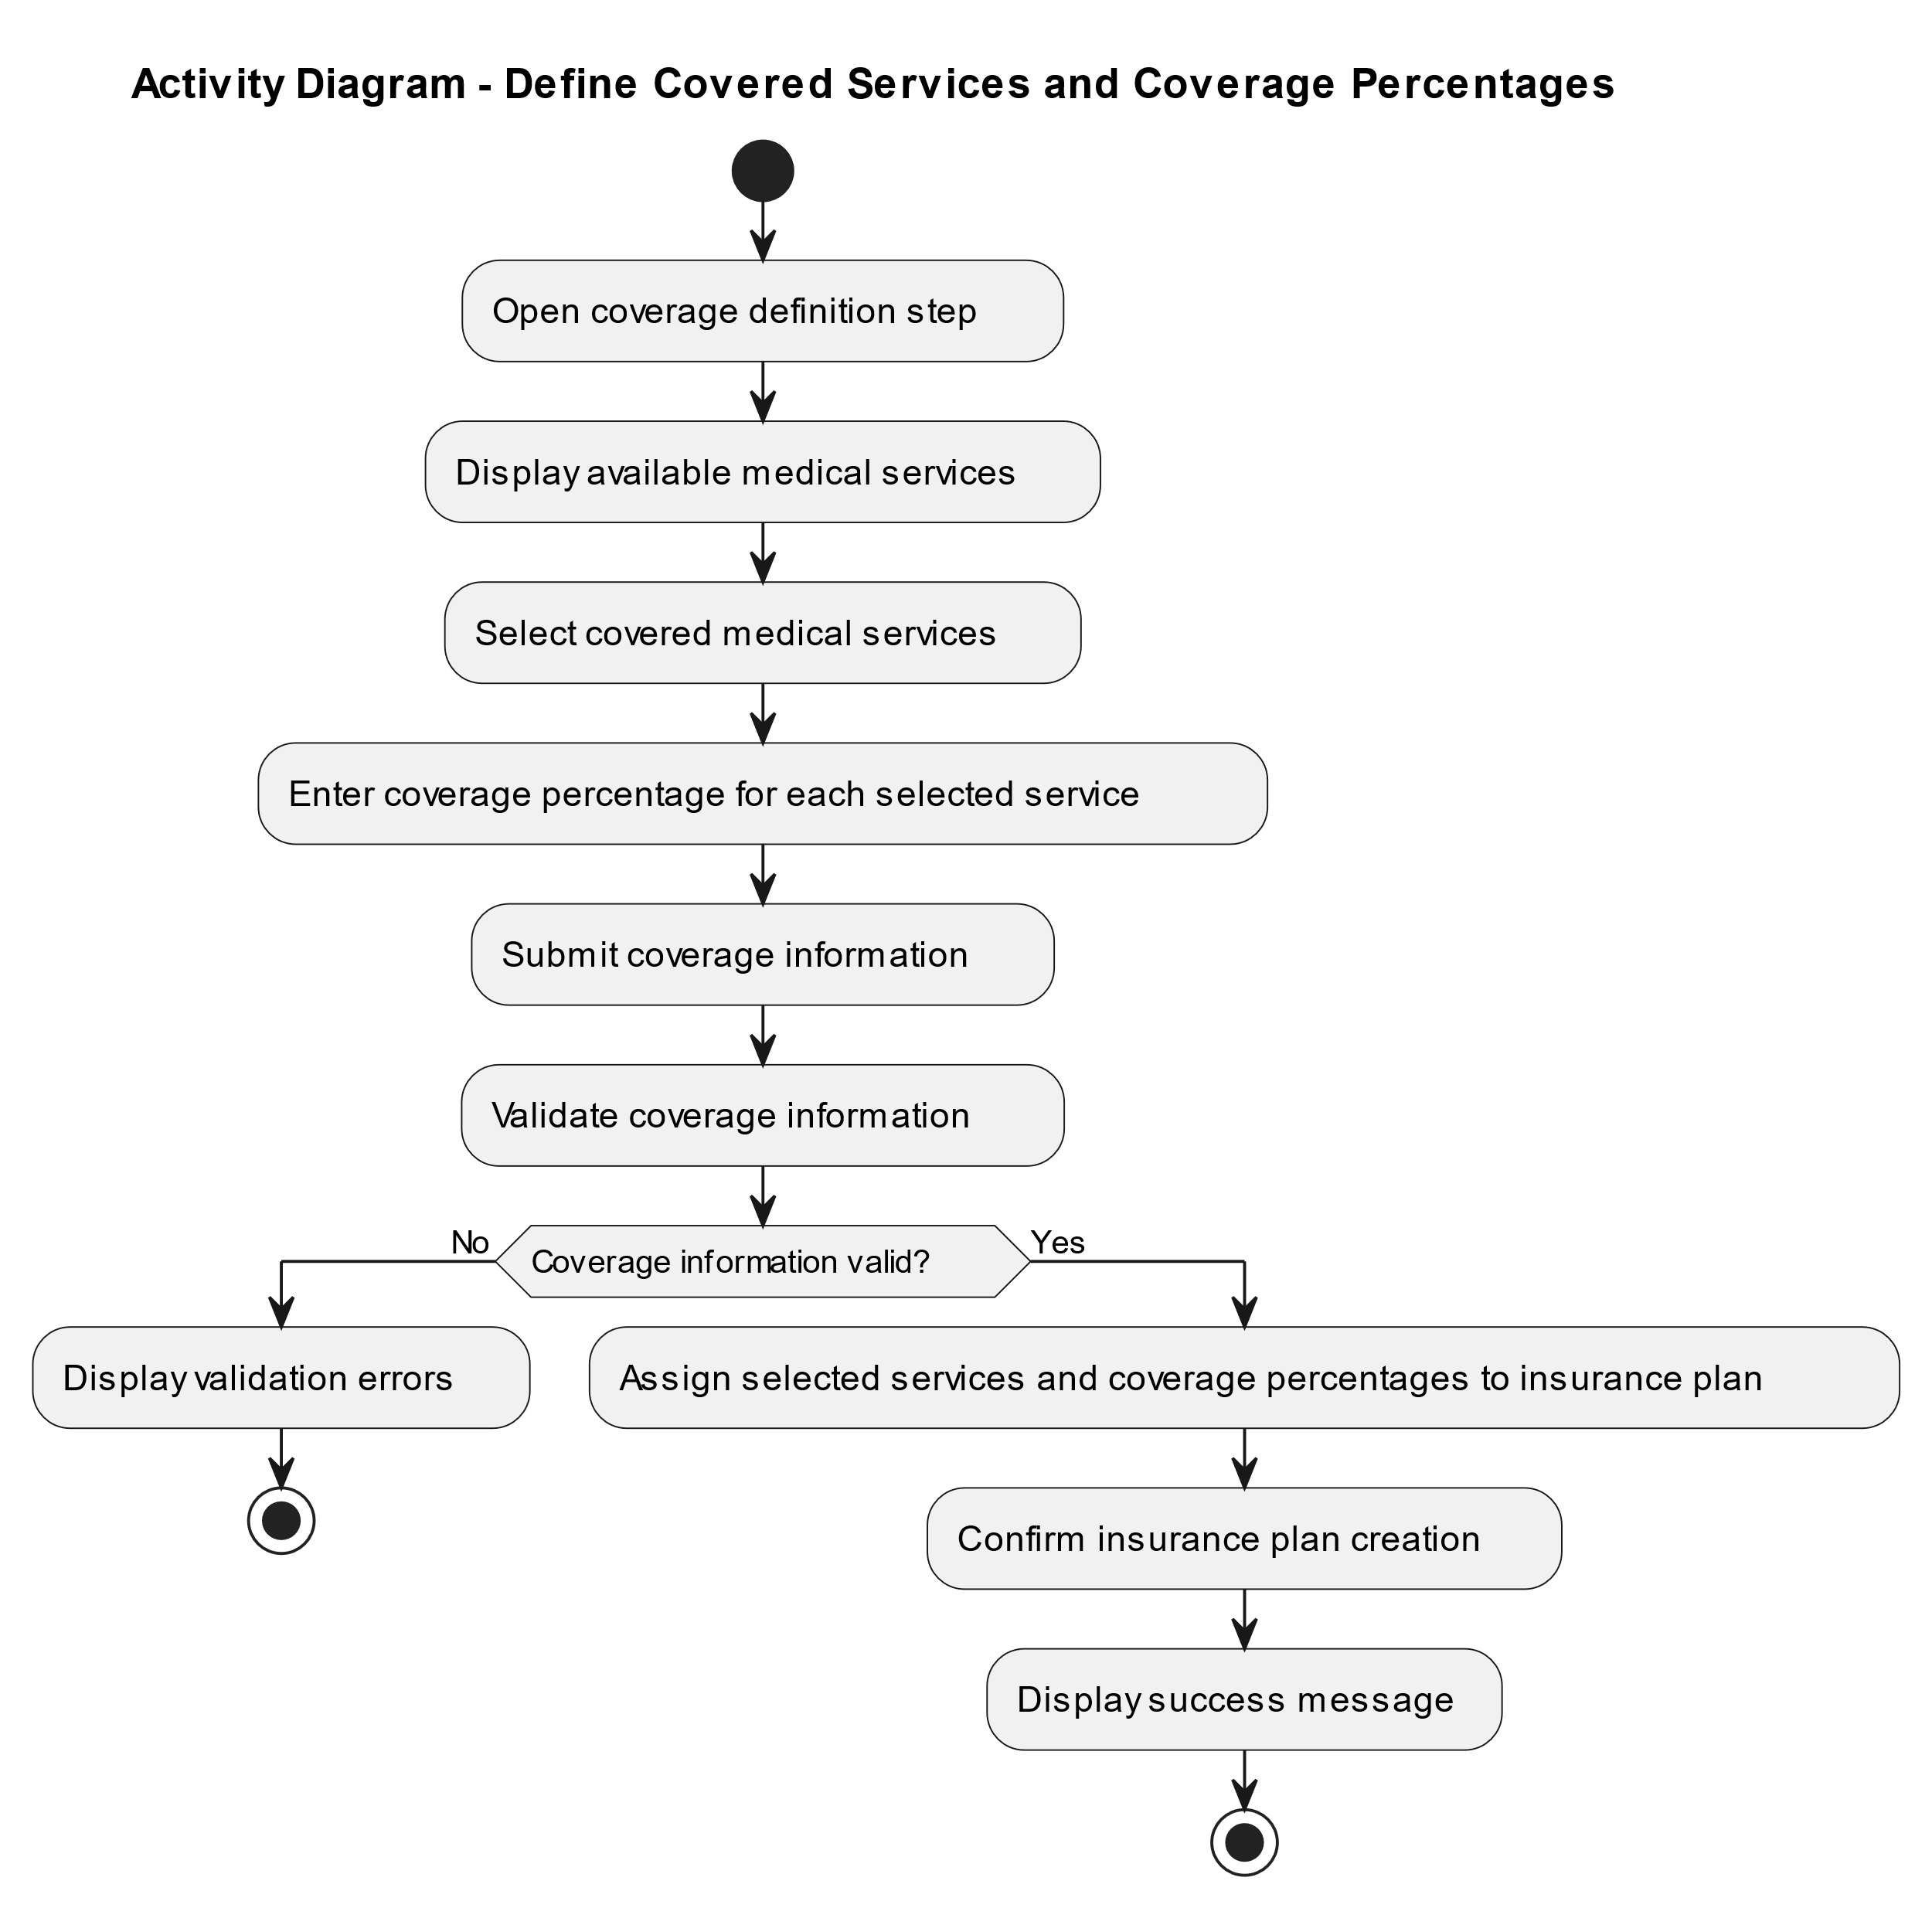
Figure 3. Activity Diagram for Defining Covered Services and Coverage Rates
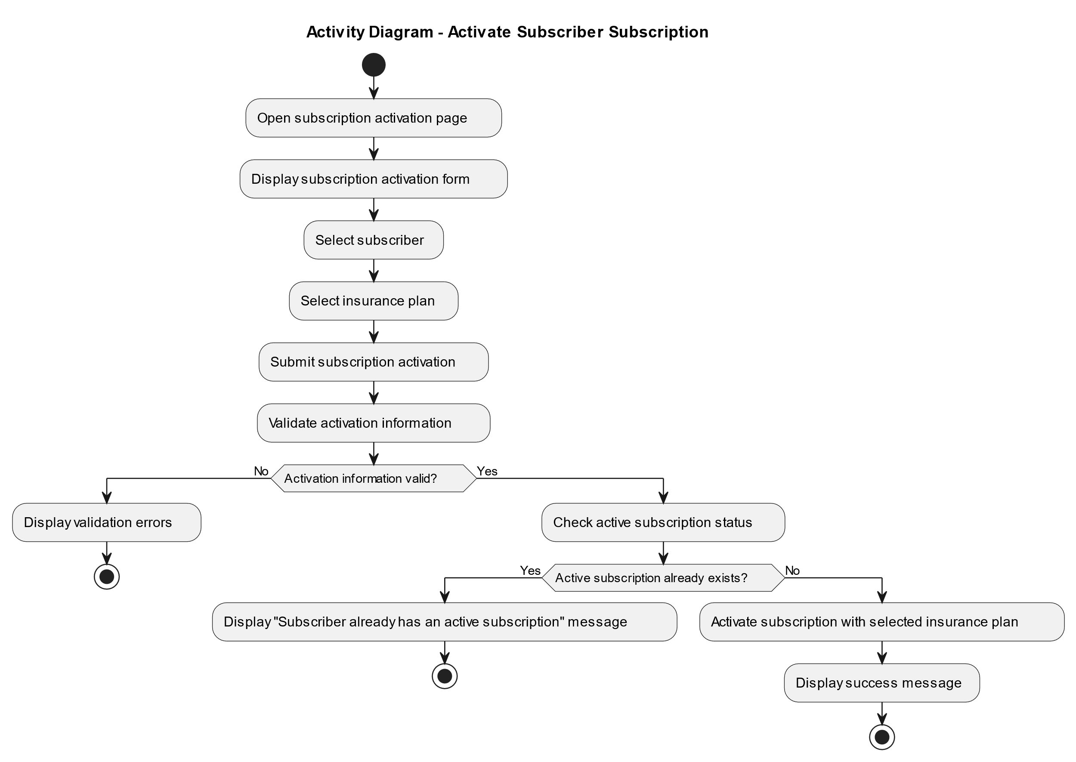
Figure 4. Activity Diagram for Activating Subscriber Subscription

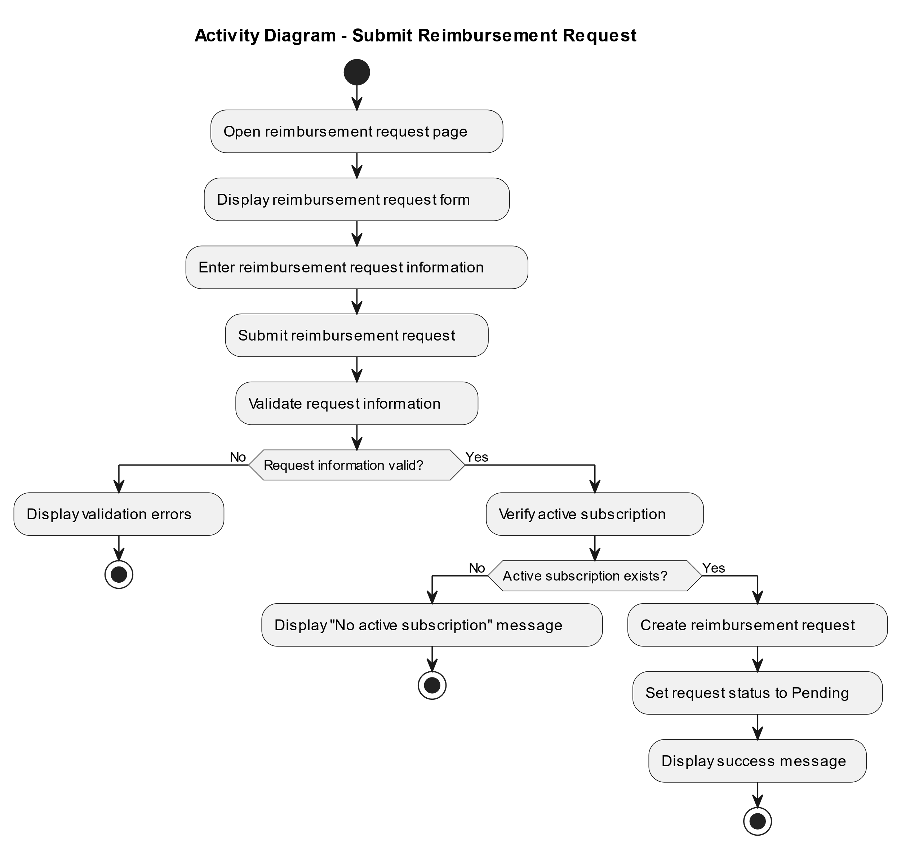
Figure 5. Activity Diagram for Submitting a Medical Reimbursement Request

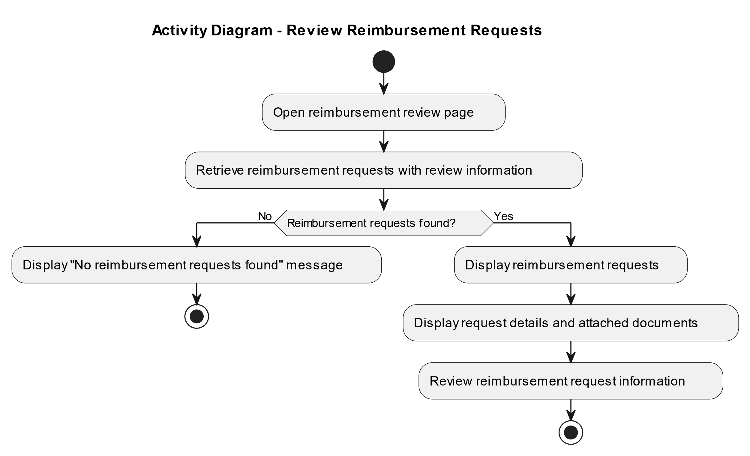
Figure 6. Activity Diagram for Reviewing Medical Reimbursement Requests

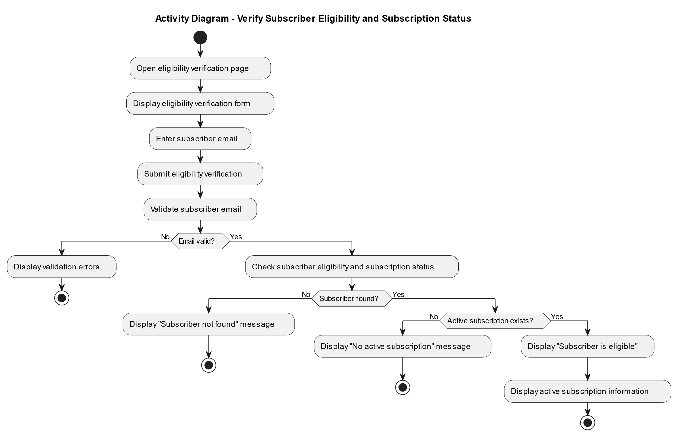
Figure 7. Activity Diagram for Checking Subscriber Eligibility and Subscription Status
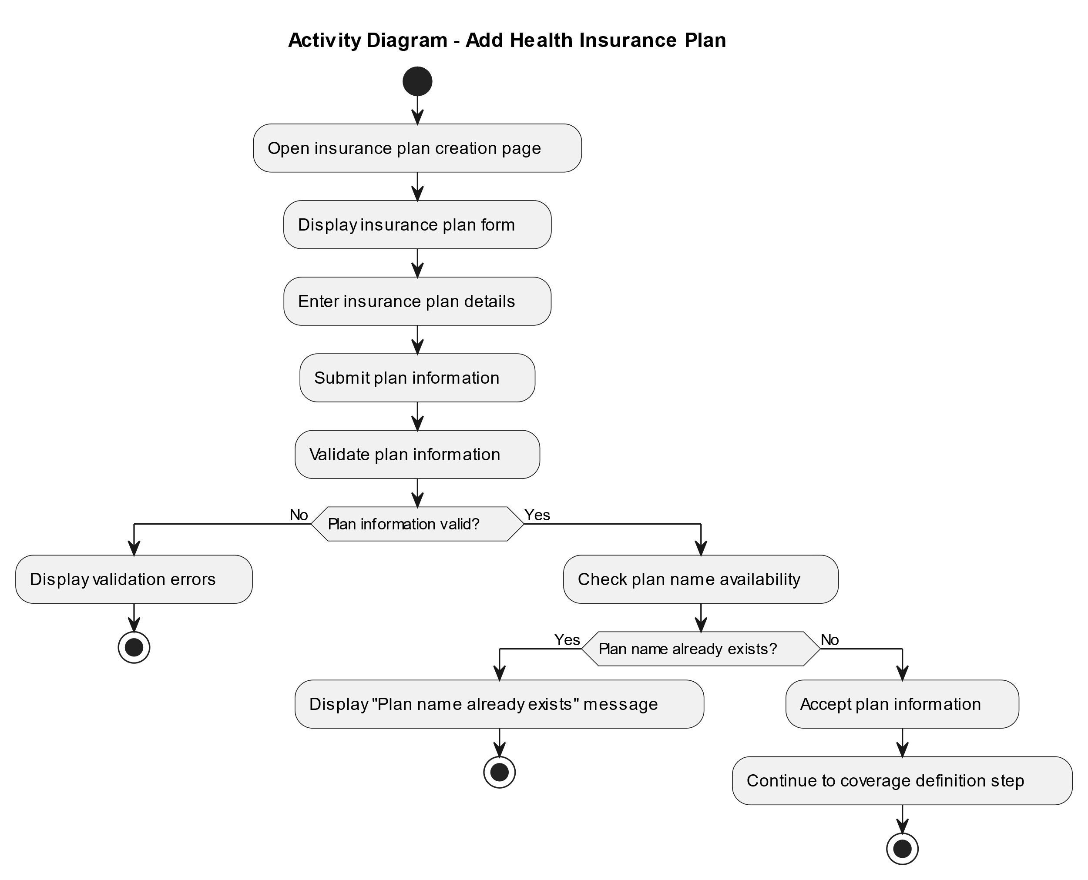
Figure 8 .Activity Diagram Add New Health Insurance Plan

4.8.4 Sequence Diagrams
Sequence diagrams are used to show the order of interactions between the system actors and the main system components over time. In this project, sequence diagrams are presented for the main use cases that represent the core workflow of the Health Insurance Management System. These diagrams focus on insurance plan and coverage definition, subscription activation, reimbursement request submission, reimbursement request review and decision, and subscriber eligibility verification.

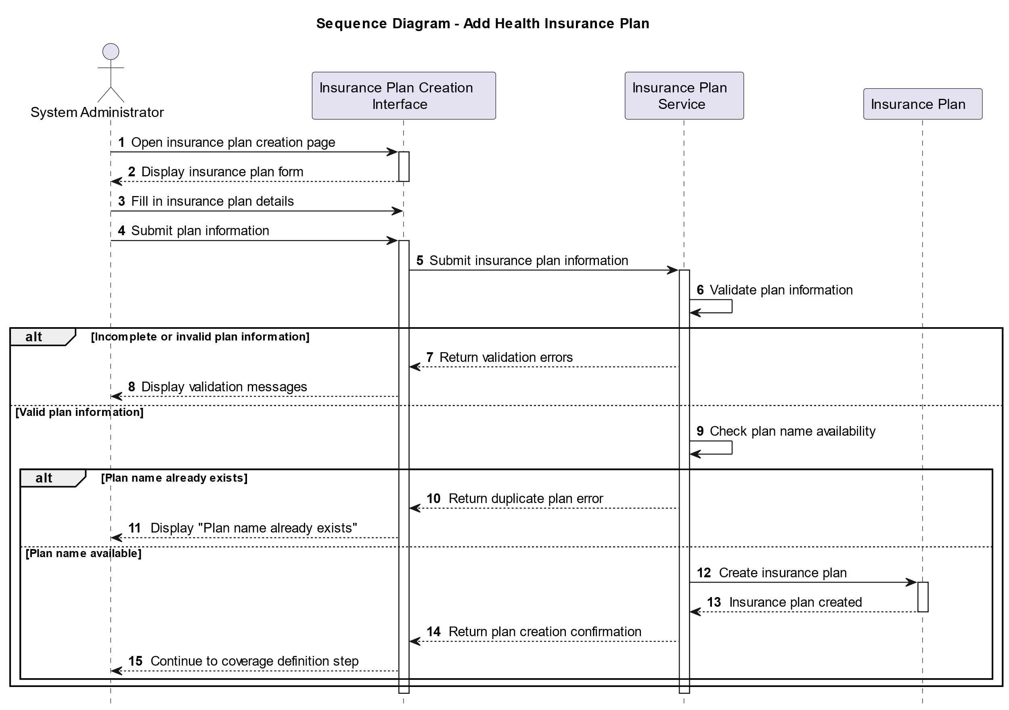
Figure 9. Sequence Diagram for Adding a New Health Insurance Plan

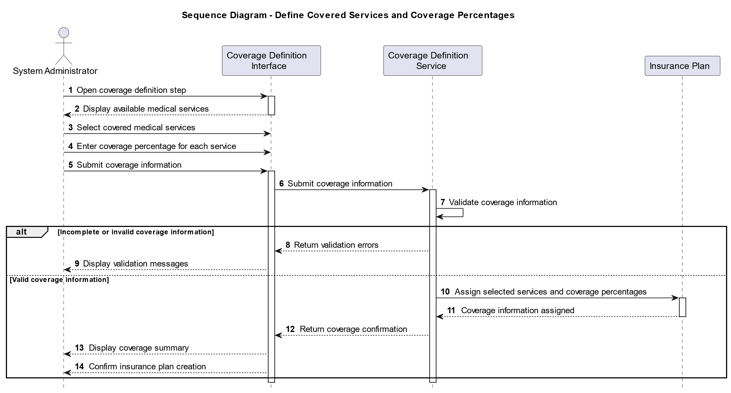
Figure 10. Sequence Diagram for Defining Covered Services and Coverage Percentages

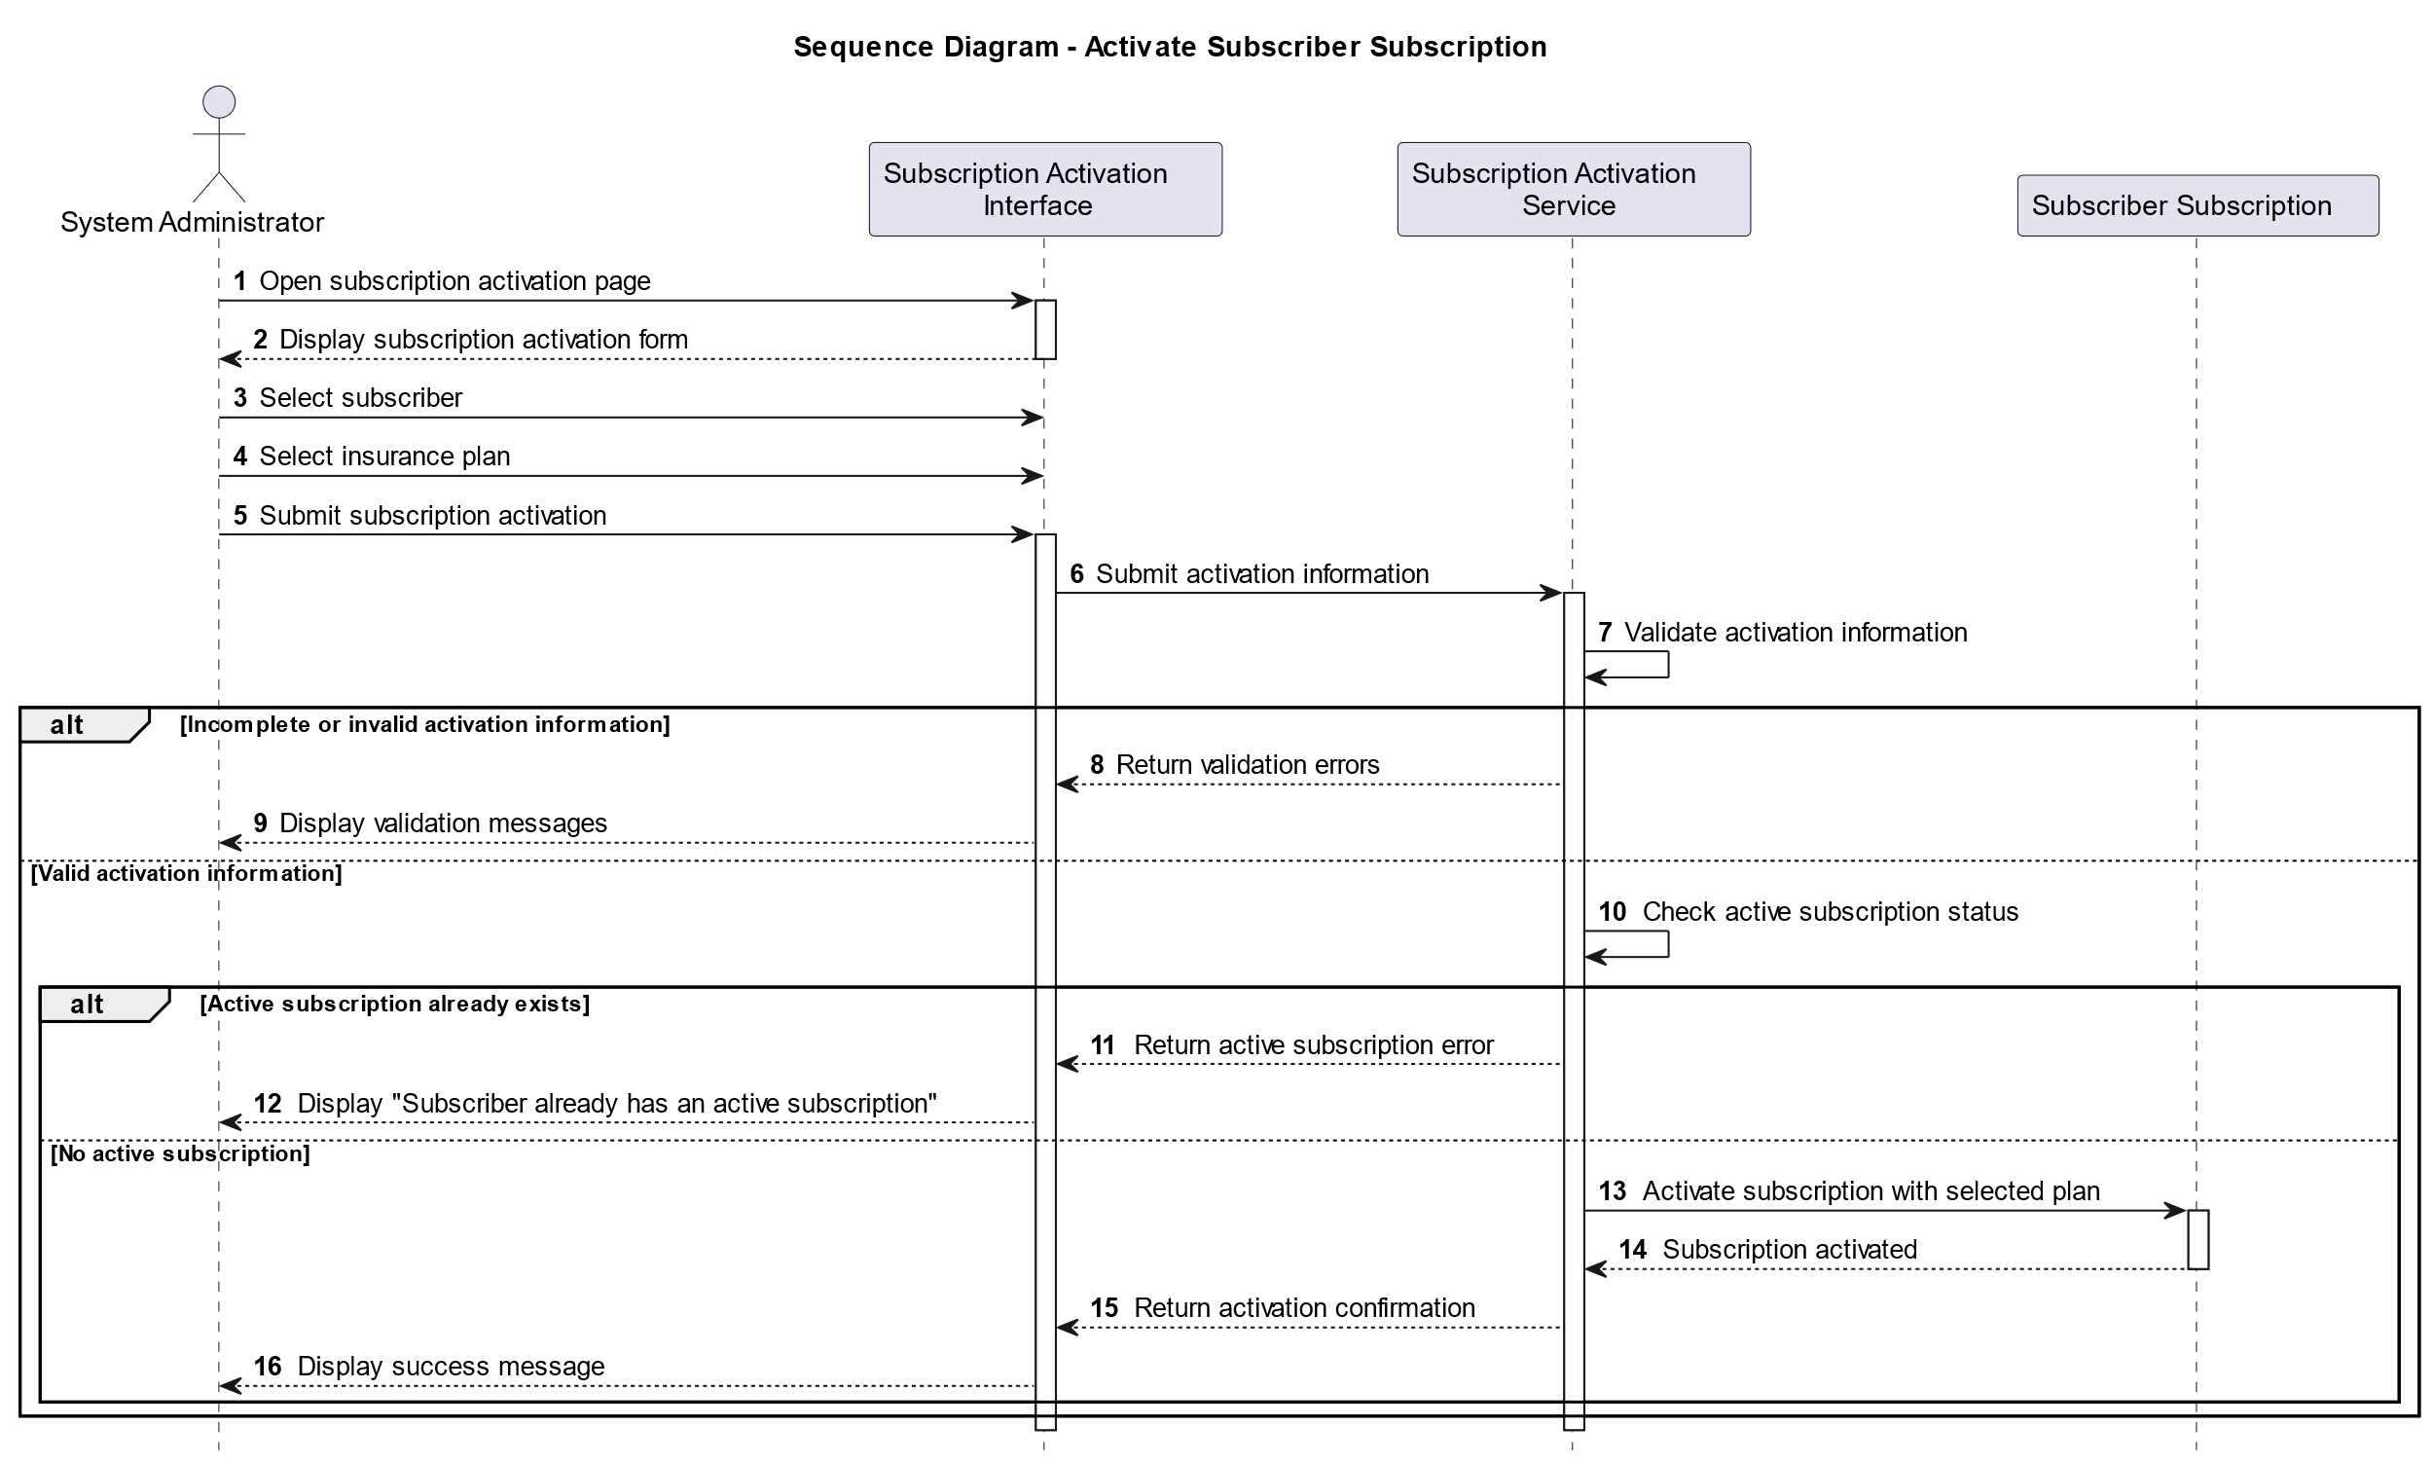
Figure 11. Sequence Diagram for Activating Subscriber Subscription

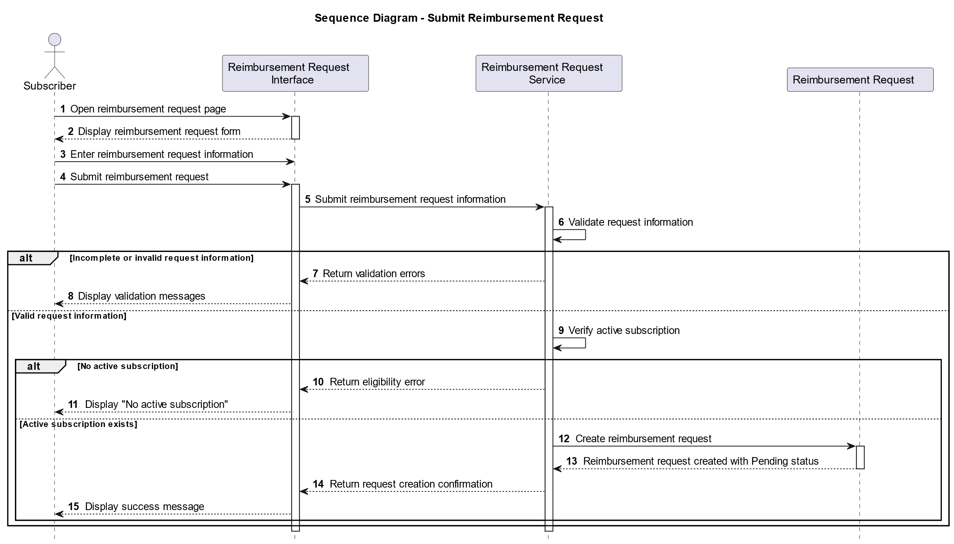
Figure 12. Sequence Diagram for Submitting a Medical Reimbursement Request

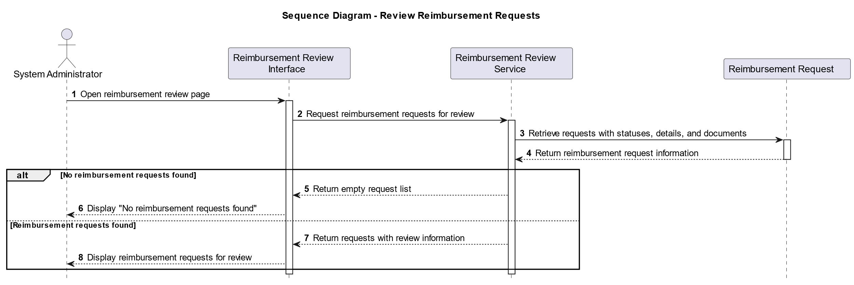

Figure 13. Sequence Diagram for Reviewing Reimbursement Requests

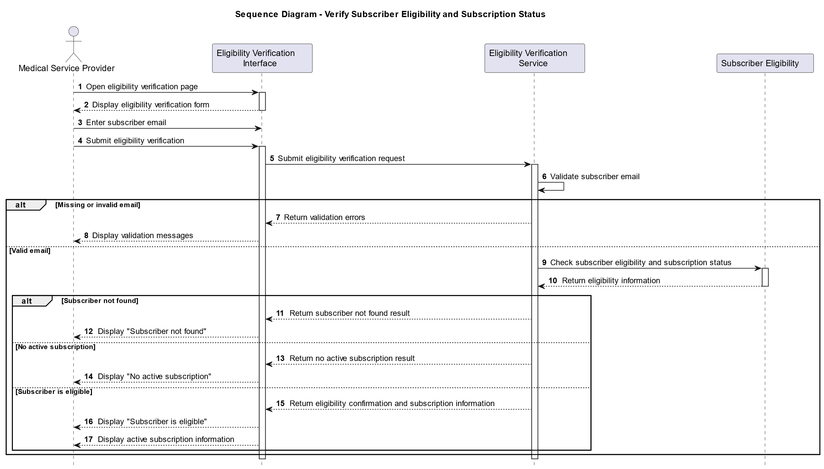
Figure 14. Sequence Diagram for Verifying Subscriber Eligibility and Subscription Status

4.8.5 Class Diagram
The Class Diagram presents the static structure of the Health Insurance Management System by identifying the main classes, their attributes, operations, and relationships. It helps clarify how the core software components are organized and how they interact with one another. The diagram also supports the transition from requirements analysis to detailed system design and implementation.
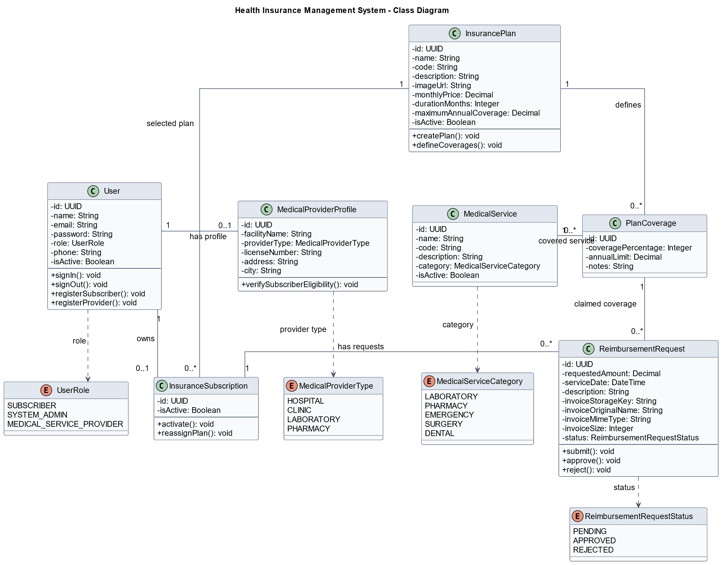
Figure 15Class Diagram of the Health Insurance Management System.

4.9 Modeling According to the Selected Methodology
The system modeling was organized according to the Incremental Development Methodology selected for this project. Since the Health Insurance Management System contains several related functions, the requirements and models were divided into smaller functional increments. Each increment represents a specific part of the system that can be analyzed, modeled, implemented, and tested gradually. The incremental approach helped organize the system analysis in a clear way. Instead of modeling the whole system as one large unit, the main functions were grouped according to their purpose and related actors. This made the use case descriptions, activity diagrams, and sequence diagrams easier to understand and more consistent with the functional requirements. The main increments of the system include account creation and role-based login, insurance plan and coverage definition, subscription activation, reimbursement request submission, reimbursement request review and decision, and subscriber eligibility verification. These increments represent the core workflow of the Health Insurance Management System.

Table 21. System Modeling According to the Incremental Methodology
Increment | Main Functions | Related Actors
Increment 1 | Account creation and role-based login | Subscriber, Medical Service Provider, System Administrator
Increment 2 | Adding health insurance plans and defining covered services | System Administrator
Increment 3 | Activating subscriber subscriptions | System Administrator
Increment 4 | Submitting reimbursement requests and uploading documents | Subscriber
Increment 5 | Reviewing, approving, or rejecting reimbursement requests | System Administrator
Increment 6 | Verifying subscriber eligibility and subscription status | Medical Service Provider

4.10 Requirements Analysis and Documentation
The requirements analysis and documentation process were carried out to ensure that the system requirements were clear, organized, and traceable. After collecting the requirements, they were classified into functional and non-functional requirements. The functional requirements were numbered from FR-01 to FR-14, while the non-functional requirements described quality aspects such as performance, security, usability, reliability, and scalability. To support traceability, a Requirements Traceability Matrix (RTM) was prepared. The RTM links each functional requirement with its related use case, design component, and initial test case. This helps ensure that every requirement is considered during analysis, design, implementation, and testing.

Table 22. Requirements Traceability Matrix
Requirement ID | Requirement Description | Source | Design Component | Test Case | Status
FR-01 | Create subscriber account | Subscriber needs | Subscriber Registration Module | TC-01 | Completed
FR-02 | Create medical service provider account | Provider needs | Provider Registration Module | TC-02 | Completed
FR-03 | Role-based login | All actors need | Authentication and Access Control Module | TC-03 | Completed
FR-04 | Add new health insurance plan | Administrator needs | Health Insurance Plan Module | TC-04 | Completed
FR-05 | Define covered services and coverage percentages | Administrator needs | Coverage Management Module | TC-05 | Completed
FR-06 | Activate subscriber subscription | Administrator needs | Subscription Management Module | TC-06 | Completed
FR-07 | View subscription and coverage details | Subscriber needs | Subscriber Dashboard Module | TC-07 | Completed
FR-08 | Submit medical reimbursement request | Subscriber needs | Reimbursement Request Module | TC-08 | Completed
FR-09 | Upload invoices and medical documents | Subscriber needs | Document Upload Module | TC-09 | Completed
FR-10 | Track reimbursement request status | Subscriber needs | Request Tracking Module | TC-10 | Completed
FR-11 | Review reimbursement requests | Administrator needs | Reimbursement Review Module | TC-11 | Completed
FR-12 | Approve reimbursement request | Administrator needs | Request Decision Module | TC-12 | Completed
FR-13 | Reject reimbursement request with reason | Administrator needs | Request Decision Module | TC-13 | Completed
FR-14 | Verify subscriber eligibility and subscription status | Provider needs | Eligibility Verification Module | TC-14 | Completed

As shown in Table 22, each functional requirement is linked to its source, related design component, initial test case, and current status. This traceability helps ensure that all requirements are considered during the design and testing phases.

4.11 Conclusion
This chapter presented the requirements analysis and system modeling of the Health Insurance Management System. It started with the feasibility study, which showed that the project is technically, economically, and operationally feasible. The chapter also presented the requirements collection process, stakeholder identification, functional requirements, non-functional requirements, and requirement prioritization. The main system actors were identified as the subscriber, the system administrator, and the medical service provider. In addition, UML diagrams were used to model the system requirements and workflows. These diagrams included the use case diagram, use case descriptions, activity diagrams, and sequence diagrams. The requirements were also organized according to the Incremental Development Methodology and supported by a Requirements Traceability Matrix. Overall, this chapter provided a clear and structured understanding of the system requirements and main processes. This analysis forms the basis for the next chapter, which focuses on the architectural and detailed design of the system.

Chapter 5: Architectural and Detailed Design

5.1 Introduction
This chapter presents the architectural and detailed design of the Health Insurance Management System. It explains how the requirements defined in the previous chapter were transformed into a structured technical design. The chapter covers the high-level system architecture, the responsibilities and interactions of the main components, the database design, the principal application operations, and the security and authorization mechanisms. This design provides the technical foundation for the implementation described in the following chapter.

5.2 High-Level System Design
The high-level system design presents the main components of the Health Insurance Management System and explains how they interact with one another. It also illustrates how user requests move from the user interface to the application and business logic, then to the data access layer and the database. This design provides a clear overview of the system structure before presenting the detailed design of its components.

5.2.1 System Block Diagram
The System Block Diagram presents a high-level view of the main components of the Health Insurance Management System and their interactions. Figure 15 shows how the system actors access the presentation layer and how their requests are processed through the application, data access, and data storage layers.
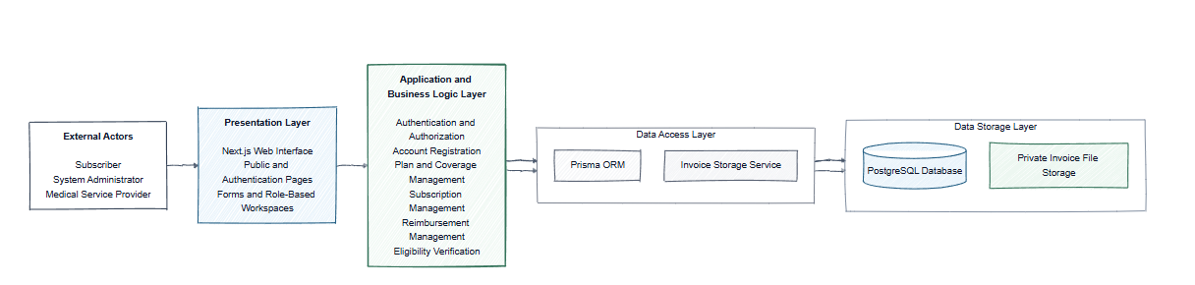
Figure 16. System Block Diagram of the Health Insurance Management System

5.2.2 Architectural Design Pattern
As illustrated in Figure 15, the Health Insurance Management System follows a Layered Architecture. The presentation layer provides the Next.js user interface, authentication pages, forms, and role-based workspaces. The application and business logic layer implements the main system operations, including authentication and authorization, account registration, plan and coverage management, subscription management, reimbursement management, and eligibility verification. The data access layer uses Prisma ORM to communicate with PostgreSQL and the Invoice Storage Service to manage reimbursement invoice files. PostgreSQL stores the structured system records and invoice metadata, while the actual invoice files are stored separately in private file storage. The Layered Architecture was selected because it provides a clear separation of responsibilities between the system components. This separation improves maintainability, testability, security, and extensibility. It also prevents direct database access from the presentation layer and allows changes to one layer with limited impact on the other layers.

5.3 Database Design
This section presents the database design of the Health Insurance Management System. It describes the main entities and the relationships between them, followed by the relational schema that defines the database tables, attributes, data types, and keys. It also presents the database constraints used to maintain data integrity and consistency, including primary keys, foreign keys, unique constraints, default values, and validation constraints.

5.3.1 Entity-Relationship Diagram
The Entity-Relationship Diagram provides a conceptual representation of the database structure of the Health Insurance Management System. It identifies the main entities, their principal attributes, and the relationships between them. The cardinalities shown in the diagram indicate how records from one entity are associated with records from another entity. Figure 16 presents the Entity-Relationship Diagram derived from the implemented Prisma database schema.
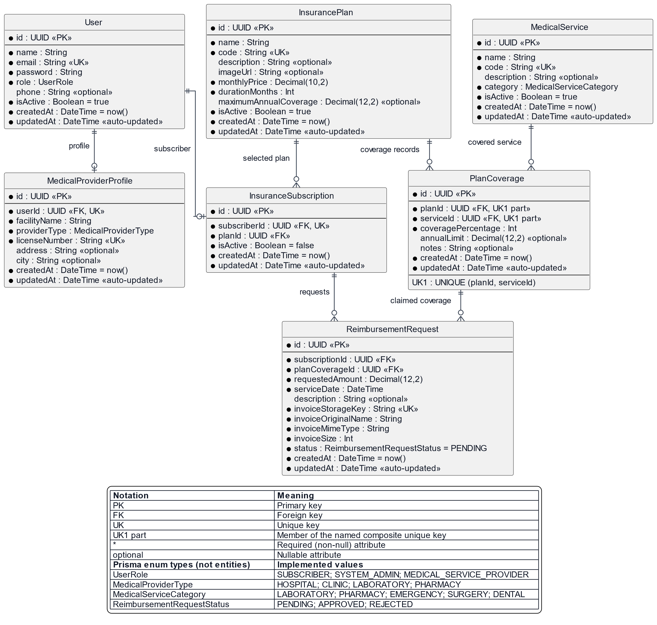
Figure 17. Entity-Relationship Diagram of the Health Insurance Management System

5.3.2 Relational Schema
The relational schema translates the entities and relationships presented in the Entity-Relationship Diagram into implemented database tables. For each relation, it specifies the attributes, data types, primary and foreign keys, nullability, default values, and important constraints. The following tables reflect the PostgreSQL database structure implemented and managed through Prisma ORM.
The User relation stores the authentication and general account information of all system users, including subscribers, system administrators, and medical service providers.
Table 23. User Relational Schema
Attribute | Data Type | Key / Constraint | Nullability | Default Value | Description
id | UUID | PK | Not Null | Generated UUID | Unique identifier of the user
name | VARCHAR | — | Not Null | — | Full name of the user
email | VARCHAR | Unique | Not Null | — | Unique email address used for authentication
password | VARCHAR | — | Not Null | — | Hashed user password
role | User Role | Enum | Not Null | — | Defines the user role in the system
phone | VARCHAR | — | Nullable | — | Optional phone number of the user
is Active | BOOLEAN | — | Not Null | true | Indicates whether the account is active
created at | TIMESTAMP | — | Not Null | Current timestamp | Date and time when the account was created
updated at | TIMESTAMP | — | Not Null | Auto-updated | Date and time of the latest modification

The UserRole attribute is implemented as an enumeration containing the following values: SUBSCRIBER, SYSTEM_ADMIN, and MEDICAL_SERVICE_PROVIDER.

Table 24MedicalProviderProfile Relational Schema
Attribute | Data Type | Key / Constraint | Nullability | Default Value | Description
id | UUID | PK | Not Null | Generated UUID | Unique identifier of the medical provider profile
userId | UUID | FK → User(id), Unique | Not Null | — | Identifies the user account associated with the medical provider
facilityName | VARCHAR | — | Not Null | — | Name of the medical facility
providerType | MedicalProviderType | Enum | Not Null | — | Defines the type of medical service provider
licenseNumber | VARCHAR | Unique | Not Null | — | Unique professional license number of the provider
address | VARCHAR | — | Nullable | — | Optional address of the medical facility
city | VARCHAR | — | Nullable | — | Optional city in which the facility is located
createdAt | TIMESTAMP | — | Not Null | Current timestamp | Date and time when the profile was created
updatedAt | TIMESTAMP | — | Not Null | Auto-updated | Date and time of the latest profile modification

The MedicalProviderType attribute is implemented as an enumeration containing the following values: HOSPITAL, CLINIC, LABORATORY, and PHARMACY.

Attribute | Data Type | Key / Constraint | Nullability | Default Value | Description
id | UUID | PK | Not Null | Generated UUID | Unique identifier of the insurance plan
name | VARCHAR | — | Not Null | — | Name of the insurance plan
code | VARCHAR | Unique | Not Null | — | Unique code assigned to the insurance plan
description | VARCHAR | — | Nullable | — | Optional description of the insurance plan
imageUrl | VARCHAR | — | Nullable | — | Optional URL of the insurance plan image
monthlyPrice | DECIMAL(10,2) | — | Not Null | — | Monthly price of the insurance plan
durationMonths | INTEGER | — | Not Null | — | Duration of the insurance plan in months
maximumAnnual  Coverage | DECIMAL(12,2) | — | Nullable | — | Optional maximum annual coverage amount
isActive | BOOLEAN | — | Not Null | true | Indicates whether the insurance plan is active
createdAt | TIMESTAMP | — | Not Null | Current timestamp | Date and time when the insurance plan was created
updatedAt | TIMESTAMP | — | Not Null | Auto-updated | Date and time of the latest plan modification
Table 25. Insurance Plan Relational Schema

Table 26 . Medical Service Relational Schema
Attribute | Data Type | Key / Constraint | Nullability | Default Value | Description
id | UUID | PK | Not Null | Generated UUID | Unique identifier of the medical service
name | VARCHAR | — | Not Null | — | Name of the medical service
code | VARCHAR | Unique | Not Null | — | Unique code assigned to the medical service
description | VARCHAR | — | Nullable | — | Optional description of the medical service
category | MedicalServiceCategory | Enum | Not Null | — | Category to which the medical service belongs
is Active | BOOLEAN | — | Not Null | true | Indicates whether the medical service is active
created at | TIMESTAMP | — | Not Null | Current timestamp | Date and time when the medical service was created
updated at | TIMESTAMP | — | Not Null | Auto-updated | Date and time of the latest service modification

Table 27. Insurance Subscription Relational Schema
Attribute | Data Type | Key / Constraint | Nullability | Default Value | Description
id | UUID | PK | Not Null | Generated UUID | Unique identifier of the insurance subscription
subscriberId | UUID | FK → User(id), Unique | Not Null | — | Identifies the subscriber associated with the subscription
planId | UUID | FK → InsurancePlan(id) | Not Null | — | Identifies the insurance plan selected by the subscriber
isActive | BOOLEAN | — | Not Null | false | Indicates whether the insurance subscription is active
createdAt | TIMESTAMP | — | Not Null | Current timestamp | Date and time when the subscription was created
updatedAt | TIMESTAMP | — | Not Null | Auto-updated | Date and time of the latest subscription modification

Table 28. Plan Coverage Relational Schema
Attribute | Data Type | Key / Constraint | Nullability | Default Value | Description
id | UUID | PK | Not Null | Generated UUID | Unique identifier of the plan coverage record
planId | UUID | FK → Insurance Plan(id), Composite Unique | Not Null | — | Identifies the insurance plan associated with the coverage
serviceId | UUID | FK → Medical Service(id), Composite Unique | Not Null | — | Identifies the medical service included in the insurance plan
coverage Percentage | INTEGER | Validation Constraint | Not Null | — | Percentage of the medical service cost covered by the plan
annual Limit | DECIMAL (12,2) | — | Nullable | — | Optional annual coverage limit for the medical service
notes | VARCHAR | — | Nullable | — | Optional notes related to the coverage
created at | TIMESTAMP | — | Not Null | Current timestamp | Date and time when the coverage record was created
updated at | TIMESTAMP | — | Not Null | Auto-updated | Date and time of the latest coverage modification

A composite unique constraint is applied to planId and serviceId to prevent the same medical service from being added more than once to the same insurance plan.

Table 29. Reimbursement Request Relational Schema
Attribute | Data Type | Key / Constraint | Nullability | Default Value | Description
id | UUID | PK | Not Null | Generated UUID | Unique identifier of the reimbursement request
subscriptionId | UUID | FK → Insurance Subscription(id) | Not Null | — | Identifies the insurance subscription used to submit the request
planCoverageId | UUID | FK → Plan Coverage(id) | Not Null | — | Identifies the plan coverage associated with the requested medical service
requested Amount | DECIMAL (12,2) | Validation Constraint | Not Null | — | Amount requested by the subscriber for reimbursement
service Date | TIMESTAMP | — | Not Null | — | Date on which the medical service was received
description | VARCHAR | — | Nullable | — | Optional description of the reimbursement request
invoiceStorageKey | VARCHAR | Unique | Not Null | — | Unique storage identifier of the uploaded invoice file
invoiceOriginalName | VARCHAR | — | Not Null | — | Original name of the uploaded invoice file
invoiceMimeType | VARCHAR | — | Not Null | — | MIME type of the uploaded invoice file
invoice Size | INTEGER | Validation Constraint | Not Null | — | Size of the uploaded invoice file
status | ReimbursementRequestStatus | Enum | Not Null | pending | Current processing status of the reimbursement request
created at | TIMESTAMP | — | Not Null | Current timestamp | Date and time when the reimbursement request was created
updated at | TIMESTAMP | — | Not Null | Auto-updated | Date and time of the latest request modification

The ReimbursementRequestStatus attribute is implemented as an enumeration containing the following values: PENDING, APPROVED, and REJECTED.

5.3.3 Database Constraints
The database applies key constraints to ensure data integrity, prevent duplication, and maintain valid relationships. Additional business rules are validated at the application layer before data is stored.
Table 30. Main Database Constraints
Constraint Type | Applied To | Purpose
Primary Key | id attribute in all relations | Uniquely identifies each record in the database
Foreign Key | MedicalProviderProfile.userId → User.id | Maintains the relationship between a provider profile and its user account
Foreign Key | InsuranceSubscription.subscriberId → User.id | Maintains the relationship between a subscription and its subscriber
Foreign Key | InsuranceSubscription.planId → InsurancePlan.id | Identifies the insurance plan selected for the subscription
Foreign Key | PlanCoverage.planId → InsurancePlan.id | Associates a coverage record with an insurance plan
Foreign Key | PlanCoverage.serviceId → MedicalService.id | Associates a coverage record with a medical service
Foreign Key | ReimbursementRequest.subscriptionId → InsuranceSubscription.id | Associates a reimbursement request with an insurance subscription
Foreign Key | ReimbursementRequest.planCoverageId → PlanCoverage.id | Associates a reimbursement request with the claimed coverage
Unique | User.email | Prevents multiple user accounts from using the same email address
Unique | MedicalProviderProfile.userId | Ensures that each user has at most one medical provider profile
Unique | MedicalProviderProfile.licenseNumber | Prevents duplicate medical provider license numbers
Unique | InsurancePlan.code | Ensures that every insurance plan has a distinct code
Unique | MedicalService.code | Ensures that every medical service has a distinct code
Unique | InsuranceSubscription.subscriberId | Ensures that each subscriber has at most one subscription record
Unique | ReimbursementRequest.invoiceStorageKey | Ensures that every uploaded invoice has a distinct storage identifier
Composite Unique | Plan Coverage (planId, serviceId) | Prevents the same medical service from being added more than once to the same insurance plan
Not Null | Required attributes | Prevents mandatory attributes from storing null values
Default Value | is Active, status, created at | Provides initial values when records are created
Referential Action | Cascade and Restrict rules | Maintains consistency when related records are deleted

5.4 API and Interface Design
This section presents the interfaces and application operations that support communication between the user interface, business logic, and data access layer. It describes the main operations used for authentication, account registration, insurance plan management, subscription management, reimbursement processing, and eligibility verification.
The system implements its main business operations through Next.js Server Actions, while Auth.js provides the authentication endpoint. The following subsections describe the implemented interfaces, their authorized actors, inputs, processing steps, successful results, and possible errors

5.4.1 Authentication and Account Registration
The authentication and account registration interfaces allow users to access the system and create accounts according to their intended roles. Auth.js manages user sessions, while Next.js Server Actions process sign-in and registration forms.

5.4.1.1 Sign in with Credentials
Implementation Type: Next.js Server Action
Action: signInAction
Authorized Actor: Public user
Input: The user provides an email address and password.
Processing: The action validates the submitted credentials and verifies that the account exists, is active, and has a valid password. When authentication succeeds, Auth.js creates a JWT-based session containing the user identifier and role.
Successful Result: The user is authenticated and redirected to the home page.
Possible Errors: Invalid email address, missing password, incorrect credentials, inactive account, or server failure.

5.4.1.2 Subscriber Registration
Implementation Type: Next.js Server Action
Action: subscriberSignUpAction
Authorized Actor: Public user
Input: The user provides a name, email address, optional phone number, password, and password confirmation.
Processing: The action validates the submitted data, verifies that the email address is not already registered, hashes the password, and creates a new user account with the SUBSCRIBER role.
Successful Result: The subscriber account is created successfully, and the user is redirected to the sign-in page.
Possible Errors: Invalid name or email address, invalid phone number, weak password, password mismatch, duplicate email address, or account creation failure.

5.4.1.3 Medical Service Provider Registration
Implementation Type: Next.js Server Action
Action: providerSignUpAction
Authorized Actor: Public user
Input: The user provides a name, email address, optional phone number, password, password confirmation, facility name, provider type, license number, optional address, and optional city.
Processing: The action validates the submitted personal and facility information, verifies that the email address is not already registered, hashes the password, and creates both the user account and the associated medical provider profile within a database transaction. The created user is assigned the MEDICAL_SERVICE_PROVIDER role.
Successful Result: The medical service provider account and its associated professional profile are created successfully, and the user is redirected to the sign-in page.
Possible Errors: Invalid personal or facility information, invalid provider type, weak password, password mismatch, duplicate email address, duplicate license number, or registration failure.

5.4.1.4 Authentication and Session Management
Implementation Type: Auth.js Authentication Endpoint
Endpoint: /api/auth/ [...nextauth]
Method: GET and POST
Authorized Actor: Public or authenticated user, depending on the requested authentication operation.
Input: The endpoint receives authentication credentials, session information, call back parameters, CSRF data, and request cookies according to the requested Auth.js operation.
Processing: Auth.js manages credentials-based sign-in, session retrieval, session updates, and sign-out operations. When the credentials are valid and the account is active, the system creates a JWT-based session containing the user identifier and role.
Successful Result: The system creates, retrieves, updates, or terminates the authenticated user session.
Possible Errors: Invalid credentials, inactive account, missing or invalid CSRF token, malformed authentication request, invalid session, or server failure.

5.4.2 Insurance Plan and Coverage Management
The insurance plan and coverage management interface allow the system administrator to create insurance plans and define the medical services covered by each plan. Each coverage record specifies the coverage percentage, optional annual limit, and additional notes for a selected medical service.

5.4.2.1 Create Insurance Plan and Coverages
Implementation Type: Next.js Server Action
Action: createInsurancePlanAction
Authorized Actor: SYSTEM_ADMIN
Input: The system administrator provides the plan name, unique code, optional description, monthly price, duration in months, optional maximum annual coverage, activation status, plan image, and a list of covered medical services. Each coverage includes a service identifier, coverage percentage, optional annual limit, and optional notes.
Processing: The action verifies the administrator's authentication and role, validates the insurance plan data, checks that the selected medical services exist and are active, validates the uploaded image, and creates the insurance plan together with its coverage records. The plan image is stored using a unique file name.
Successful Result: The insurance plan and its associated coverage records are created successfully, and the system returns the identifier of the newly created plan.
Possible Errors: Unauthenticated user, unauthorized role, invalid plan information, duplicate plan code, missing or invalid plan image, duplicate medical services, invalid coverage percentage, inactive or unavailable medical service, or server failure.

5.4.3 Subscription Management
The subscription management interface allows the system administrator to assign an active insurance plan to a subscriber. The system verifies the subscriber and plan information before creating or updating the subscriber's insurance subscription.

5.4.3.1 Activate or Reassign an Insurance Subscription
Implementation Type: Next.js Server Action
Action: activateInsuranceSubscriptionAction
Authorized Actor: SYSTEM_ADMIN
Input: The system administrator provides the subscriber identifier and the insurance plan identifier.
Processing: The action verifies that the administrator is authenticated and authorized, validates the submitted identifiers, confirms that the selected user has the SUBSCRIBER role, and checks that the insurance plan exists and is active. It then creates a new subscription or updates the subscriber's existing inactive subscription with the selected plan and activates it.
Successful Result: The subscriber's insurance subscription is created or activated successfully, the subscription management page is revalidated, and the administrator is redirected to the home page.
Possible Errors: Unauthenticated user, unauthorized role, invalid subscriber or plan identifier, subscriber not found, selected user is not a subscriber, insurance plan not found, inactive insurance plan, subscriber already has an active subscription, or server failure.

5.4.4 Reimbursement Management
The reimbursement management interfaces allow subscribers to submit reimbursement requests with invoice evidence and enable system administrators to review and decide on pending requests. Each request is associated with an active insurance subscription and a specific plan coverage record.

5.4.4.1 Submit Reimbursement Request
Implementation Type: Next.js Server Action
Action: createReimbursementRequestAction
Authorized Actor: SUBSCRIBER
Input: The subscriber provides the plan coverage identifier, service date, requested amount, optional description, and a required invoice file.
Processing: The action verifies that the subscriber is authenticated and authorized, validates the submitted information, and checks that the subscriber has an active insurance subscription. It also verifies that the selected coverage belongs to the subscriber's insurance plan and is eligible for reimbursement. The uploaded invoice must be a valid PDF, PNG, or JPEG file with a maximum size of 5 MB. The file is stored in private storage using a randomized name, while its metadata is recorded in the database.
Successful Result: A new reimbursement request is created with the PENDING status, the claims page is revalidated, and the subscriber is redirected to the claims page with a successful submission indicator.
Possible Errors: Unauthenticated user, unauthorized role, invalid coverage identifier, invalid or future service date, invalid requested amount, missing active subscription, unavailable or ineligible coverage, missing or invalid invoice file, unsupported file type, file size exceeding 5 MB, storage failure, or database error.

5.4.4.2 Approve Reimbursement Request
Implementation Type: Next.js Server Action
Action: approveReimbursementRequestAction
Authorized Actor: SYSTEM_ADMIN
Input: The system administrator provides the reimbursement request identifier.
Processing: The action verifies the administrator's authentication and role, validates the request identifier, and checks that the reimbursement request exists and is still in the PENDING state. It then atomically changes the request status to APPROVED.
Successful Result: The reimbursement request is approved successfully, and both the administrator and subscriber claims pages are revalidated.
Possible Errors: Unauthenticated user, unauthorized role, invalid request identifier, reimbursement request not found, request already reviewed, or database failure.

5.4.4.3 Reject Reimbursement Request
Implementation Type: Next.js Server Action
Action: RejectReimbursementRequestAction
Authorized Actor: SYSTEM_ADMIN
Input: The system administrator provides the reimbursement request identifier.
Processing: The action verifies the administrator's authentication and role, validates the request identifier, and checks that the reimbursement request exists and remains in the PENDING state. It then atomically changes the request status to REJECTED.
Successful Result: The reimbursement request is rejected successfully, and both the administrator and subscriber claims pages are revalidated.
Possible Errors: Unauthenticated user, unauthorized role, invalid request identifier, reimbursement request not found, request already reviewed, or database failure.

5.4.5 Eligibility Verification
The eligibility verification interface allows medical service providers to verify whether a subscriber has an active insurance subscription before providing a covered medical service.

5.4.5.1 Verify Subscriber Eligibility
Implementation Type: Next.js Server Action
Action: checkSubscriberEligibilityAction
Authorized Actor: MEDICAL_SERVICE_PROVIDER
Input: The medical service provider enters the subscriber's email address.
Processing: The action verifies that the medical service provider is authenticated and authorized, validates and normalizes the submitted email address, searches for a user with the SUBSCRIBER role, and checks whether the subscriber has an active insurance subscription.
Successful Result: The system confirms that the subscriber is eligible and returns the subscriber's name, email address, active subscription status, insurance plan name, and plan code.
Possible Errors: Unauthenticated user, unauthorized role, missing or invalid email address, subscriber account not found, no insurance subscription assigned, inactive subscription, or server failure.

5.5 Security and Authorization Design
The security design of the Health Insurance Management System protects user accounts, restricts access according to user roles, validates submitted data, and secures uploaded reimbursement invoices. The system combines Auth.js authentication, JWT-based sessions, role-based authorization, password hashing, input validation, and private file storage to protect sensitive operations and system data.

5.5.1 Authentication Design
The system uses Auth.js with a credentials-based authentication mechanism. Users sign in using their email address and password. During authentication, the system verifies that the submitted credentials are valid, that the account exists, and that the account is active. When authentication succeeds, a JWT-based session is created and includes the user identifier and assigned role. The session is subsequently used to identify the user and protect secured operations.

5.5.2 Role-Based Authorization
The system applies Role-Based Access Control to restrict protected operations according to the authenticated user's assigned role. Three roles are supported: SUBSCRIBER, SYSTEM_ADMIN, and MEDICAL_SERVICE_PROVIDER. Each protected Server Action verifies the existence of a valid session and checks the user's exact role before executing the requested operation. The SYSTEM_ADMIN role is authorized to create insurance plans and coverages, activate subscriber subscriptions, and approve or reject reimbursement requests. The SUBSCRIBER role can submit reimbursement requests associated with an active insurance subscription. The MEDICAL_SERVICE_PROVIDER role can verify subscriber eligibility. Requests from unauthenticated users or users with an unauthorized role are rejected before any database modification is performed.

5.5.3 Password and Session Security
User passwords are not stored in plain text. During account registration, passwords are hashed using bcrypt before being stored in the database. The registration forms also require passwords to satisfy defined length and complexity rules and to match the confirmation value.
After successful authentication, Auth.js creates a JWT-based session containing the user identifier and assigned role. This session information is used by protected Server Actions to authenticate the user and enforce role-based authorization. Authentication failures use general error messages to avoid revealing whether an account exists, is inactive, or has an incorrect password.

5.5.4 Input and File Upload Security
All-important inputs are validated on the server before business operations or database changes are performed. The validation process checks required fields, email formats, UUID identifiers, numeric values, dates, enumeration values, text lengths, and business-specific conditions. Server-side validation prevents users from bypassing the restrictions applied by the user interface.
Reimbursement invoice uploads are subject to additional security checks. The file must be non-empty, must not exceed 5 MB, and must be a PDF, PNG, or JPEG file. The system verifies both the declared MIME type and the actual file signature to reduce the risk of uploading a disguised malicious file. Accepted invoices are stored in private storage using randomized file names, while only their metadata is stored in PostgreSQL.

5.5.5 Data Protection and Error Handling
Structured application data is stored in PostgreSQL and accessed through Prisma ORM. Database constraints, including primary keys, foreign keys, unique constraints, and referential actions, help preserve data integrity and prevent invalid relationships or duplicate records.
Sensitive reimbursement invoice files are separated from their database metadata and stored in private file storage. The current implementation does not expose a public invoice download interface, which prevents direct access through a public application route. When an invoice is saved but the related database operation fails, the system attempts to remove the stored file to avoid leaving unused files.
Error handling provides clear feedback without exposing passwords, internal database details, storage paths, or other sensitive implementation information. Authentication, authorization, validation, conflict, and server errors are handled separately according to the operation being performed.

5.6 Chapter Summary
This chapter presented the architectural and detailed design of the Health Insurance Management System. It described the layered architecture and the interactions between the presentation, business logic, data access, and storage layers. It also documented the Entity-Relationship Diagram, relational schema, database constraints, implemented application interfaces, and security mechanisms. The resulting design provides a structured foundation for the implementation environment and programming details presented in the following chapter.

Chapter 6: Development Environment and Software Implementation

6.1 Programming Tools and Libraries
The Health Insurance Management System was developed using a modern web technology stack that supports secure, scalable, and maintainable application development. The following sections present the main software tools, libraries, and technologies used during the implementation of the system.

Table 31. Programming Tools and Libraries Used in the Project
Tool / Library | Version | Purpose
Visual Studio Code | Latest Stable | Source code editor and integrated development environment
Node.js | 22.x | JavaScript runtime environment
npm | 10.x | Package manager for JavaScript dependencies
Next.js | 15.x | Full-stack React framework for web application development
React | 19.x | Building interactive user interfaces
TypeScript | 5.x | Type-safe programming language
Tailwind CSS | 4.x | User interface styling framework
Prisma ORM | 6.x | Object-relational mapping and database access
PostgreSQL | 17.x | Relational database management system
Auth.js | 5.x | Authentication and session management
Zod | 4.x | Server-side input validation
Git | Latest Stable | Version control system
PlantUML | Latest Stable | UML diagram generation
Draw.io | Latest Stable | System architecture and software design diagrams

6.2 Development Environment
The Health Insurance Management System was developed in a local development environment configured to support modern full-stack web application development. The environment includes the operating system, integrated development environment, project structure, runtime environment, and web browser used throughout the implementation process.

6.2.1 Development Environment Configuration

Table 32. Development Environment Configuration
Component | Technology | Purpose
Operating System | Windows 11 | Development and testing environment
IDE | Visual Studio Code | Source code editing and debugging
Runtime Environment | Node.js | Executing the Next.js application
Package Manager | npm | Managing project dependencies
Database Administration | pgAdmin 4 | Managing PostgreSQL databases
Web Browser | Google Chrome | Testing and debugging the web application
Project Structure | Next.js App Router | Organizing application pages, layouts, and server actions

The project was implemented using Visual Studio Code as the primary development environment. Google Chrome was used to test and debug the application during development. The project follows the Next.js App Router architecture, which organizes pages, layouts, components, and server actions into a structured directory hierarchy.

6.3 Programming Languages and Frameworks
The Health Insurance Management System was implemented using modern programming languages and web development frameworks that provide scalability, maintainability, security, and high development productivity. Each technology was selected according to its role within the system architecture and its compatibility with the overall application requirements.

6.3.1 TypeScript
TypeScript was used as the primary programming language for the project. It extends JavaScript by adding static typing, which improves code reliability, reduces programming errors, and provides better support for large-scale application development. The strong type system also enhances code readability and simplifies maintenance throughout the development process.

6.3.2 Next.js
Next.js was selected as the main full-stack web framework for the Health Insurance Management System. It provides the App Router architecture, Server Actions, server-side rendering, optimized routing, and efficient integration between the presentation layer and business logic. These features simplify application development while improving performance, scalability, and security.

6.3.3 React
React was used to develop the interactive user interface of the application. Its component-based architecture enables the creation of reusable interface elements, improves maintainability, and simplifies the development of dynamic web pages. React also integrates seamlessly with Next.js, providing an efficient development workflow.

6.3.4 Prisma ORM
Prisma ORM was used to manage database access and communication with PostgreSQL. It provides a type-safe interface for database operations, simplifies query implementation, supports database migrations, and reduces the complexity of interacting with relational data. Prisma also improves consistency between the application models and the database schema.

6.3.5 PostgreSQL
PostgreSQL was selected as the relational database management system because of its reliability, performance, and support for complex relational data structures. It stores the application's structured data, including users, insurance plans, subscriptions, coverage records, and reimbursement requests.

6.3.6 Tailwind CSS
Tailwind CSS was used to build the application's user interface. It provides a utility-first styling approach that simplifies responsive interface development, reduces custom CSS code, and improves consistency across the application.

6.3.7 Auth.js
Auth.js was integrated to implement authentication and session management. It supports secure credentials-based authentication, JWT sessions, and role-based access control. The framework simplifies user authentication while providing a secure and extensible authentication mechanism.

6.3.8 Zod
Zod was used for server-side input validation. It validates user input before executing business operations, ensuring that submitted data satisfies the required formats and constraints. This validation layer improves application security and reduces invalid database operations.

6.4 Database Server and Operating System
The Health Insurance Management System was developed and tested in a local development environment. The application uses PostgreSQL as the database management system and runs on a Windows operating system during development. This environment provides a stable platform for implementing, testing, and debugging the application.

6.4.1 Database Server
PostgreSQL was selected as the database server because it is an open-source relational database management system that offers reliability, performance, and strong support for complex relational data. It stores all structured application data, including user accounts, insurance plans, medical services, subscriptions, coverage records, reimbursement requests, and invoice metadata. Prisma ORM communicates directly with PostgreSQL to perform database queries, updates, and transactions while maintaining type safety and consistency between the application models and the database schema.

6.4.2 Operating System
The development and testing of the Health Insurance Management System were performed on the Microsoft Windows 11 operating system. Windows provides a stable environment for running Node.js, PostgreSQL, Visual Studio Code, and other development tools used throughout the implementation process. It also supports efficient project management, debugging, and local application testing.

6.5 Project Dependencies
The Health Insurance Management System depends on several external libraries to support authentication, database access, input validation, user interface development, and file handling. These dependencies simplify the implementation process, improve code maintainability, and provide reliable solutions for common development tasks.

6.5.1 Main Project Dependencies
Table 33. Main Project Dependencies
Dependency | Purpose | Category
Next.js | Full-stack web application framework | Framework
React | Building interactive user interfaces | UI Library
TypeScript | Static type checking | Programming Language
Prisma ORM | Database access and ORM | Database
PostgreSQL | Relational database management | Database
Auth.js | User authentication and session management | Authentication
Zod | Server-side input validation | Validation
Tailwind CSS | User interface styling | CSS Framework
bcrypt | Password hashing | Security
React Hook Form | Form state management | Forms

6.6 Version Control
Version control was used throughout the development of the Health Insurance Management System to manage source code changes, maintain development history, and support incremental implementation. Git was selected as the version control system because it provides reliable change tracking and simplifies project maintenance.

6.6.1 Git Repository
Git was used to track modifications made during the implementation of the project. Source code changes were recorded through commits with descriptive messages, allowing different development stages to be documented and restored when necessary. This approach reduced the risk of losing work and simplified debugging during development.

6.6.2 GitHub Repository
The project repository was hosted on GitHub to maintain a secure remote copy of the source code. GitHub provided centralized version management and facilitated backup throughout the implementation process. The remote repository also preserved the complete development history and supported synchronization between the local and remote project versions.

6.7 Continuous Integration and Deployment (CI/CD)
The current implementation of the Health Insurance Management System does not include an automated Continuous Integration and Continuous Deployment (CI/CD) pipeline. The project was developed and tested locally during the implementation phase. Source code versions were managed using Git and GitHub, while application execution, testing, and debugging were performed manually in the local development environment.

6.8 Testing Environment
The Health Insurance Management System was tested locally to verify that its implemented features satisfied the specified functional requirements.
Table 34. Testing Environment Configuration
Component | Technology | Purpose
Testing Environment | Localhost | Local execution and functional testing
Operating System | Windows 11 | Application development and testing
Runtime Environment | Node.js 22.x | Running the Next.js application
Web Framework | Next.js | Executing the web application
Database Server | PostgreSQL 17 | Storing application data
Database Administration | pgAdmin 4 | Managing the PostgreSQL database
Web Browser | Google Chrome | Testing and verifying the user interface

6.9 Software Implementation
This section presents representative implementation examples of the Health Insurance Management System. Instead of including the complete source code, selected code excerpts are provided to illustrate the implementation of the main system components and core functionalities.

6.9.1 Project Structure
Figure 17 illustrates the high-level directory structure of the Health Insurance Management System. The project follows the Next.js App Router architecture and is organized into separate directories for application pages, reusable components, business logic, database configuration, validation, and static resources.

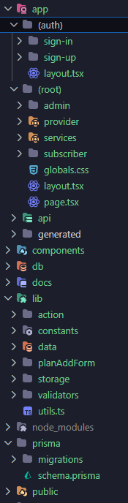
Figure 18. High-Level Directory Structure of the Health Insurance Management System

6.9.2 Authentication Module
The authentication module manages user registration, sign-in, session management, and role-based access control. It is implemented using Auth.js, Next.js Server Actions, and Zod validation to ensure secure authentication and authorization.
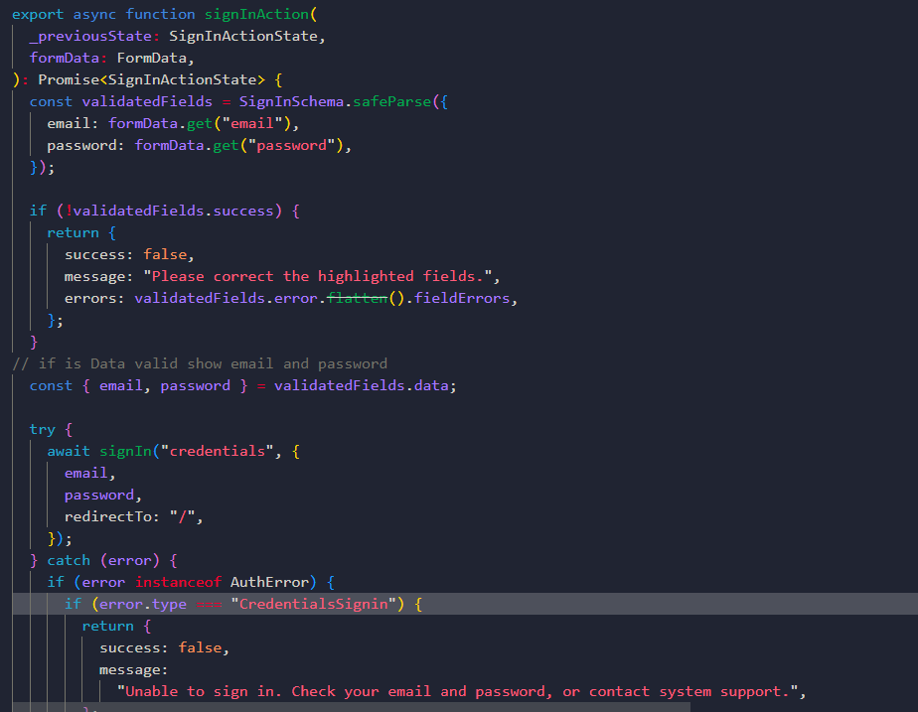
Figure 19. Representative Code of the Sign-In Logic
The code validates the submitted email address and password, attempts to authenticate the user through Auth.js, and handles authentication failures using general error messages. When authentication succeeds, the system creates the user session and redirects the user to the appropriate page.

6.9.3 Insurance Plan Management Module
The insurance plan management module allows the system administrator to create insurance plans and define the medical services covered by each plan. The following code excerpt illustrates the main logic used to validate plan data, verify selected medical services, and create the insurance plan together with its coverage records.
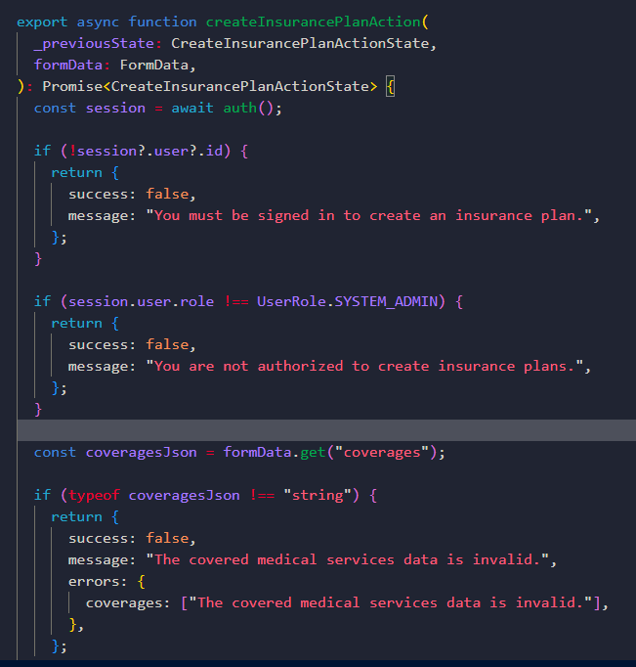
Figure 20. Authentication and Validation Logic for Insurance Plan Creation
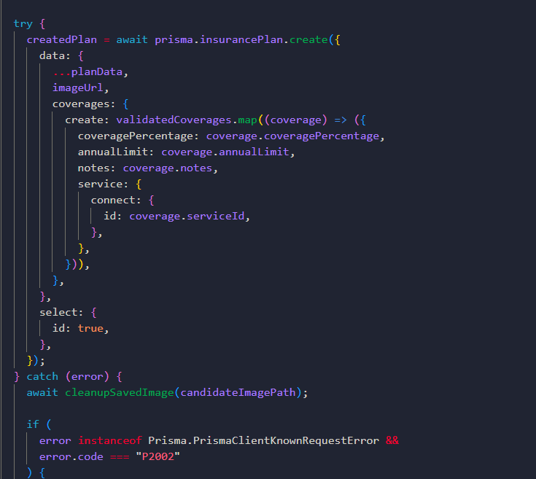
Figure 21. Database Creation Logic for the Insurance Plan and Coverages

6.9.4 Subscription Management Module

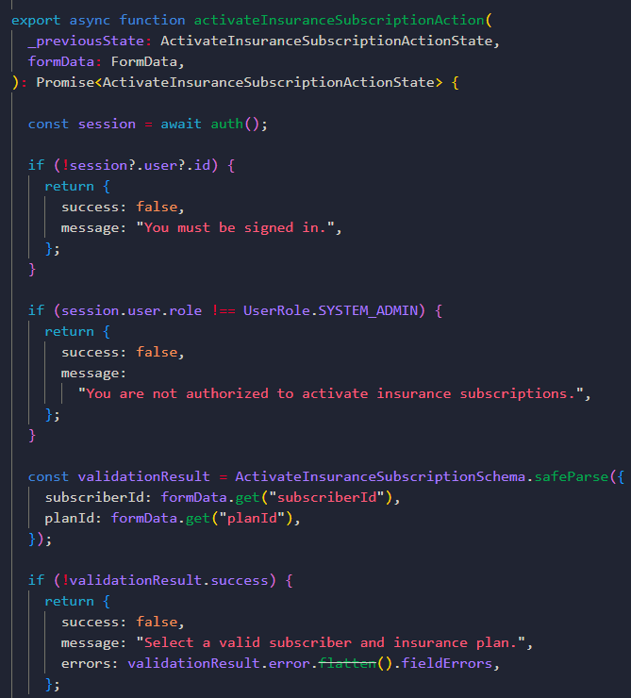
Figure 22.check the role before activation

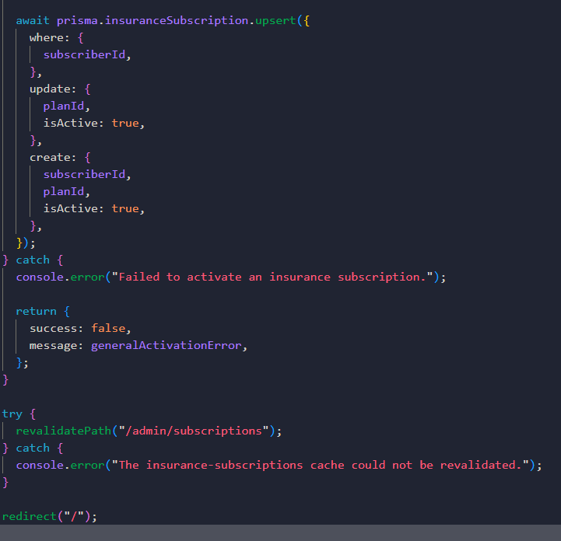
Figure 23. Implementation of Insurance Subscription Activation and Reassignment

6.9.5 Reimbursement Management Module

‘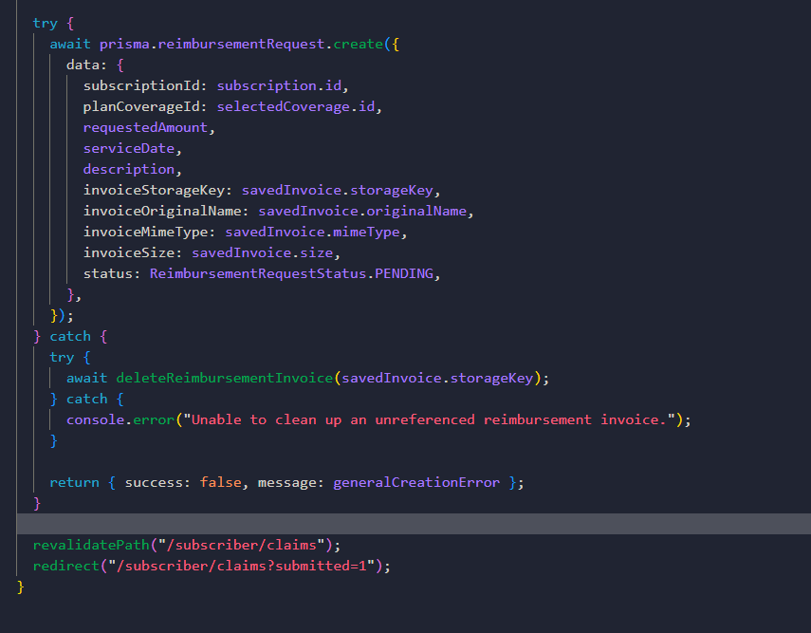
Figure 24. Logic for Reimbursement Request Submission

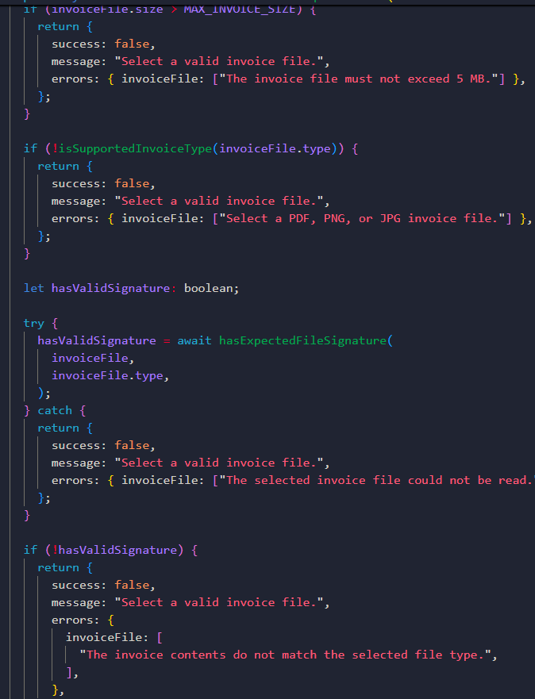
Figure 25. Invoice Validation and Private File Storage

6.9.6 Data Access Layer Implementation
The data access layer was implemented using Prisma ORM to provide type-safe communication between the application and the PostgreSQL database. This layer is responsible for executing database queries, creating and updating records, retrieving structured data, and maintaining consistency between the application models and the relational schema.
The following code excerpt illustrates how Prisma ORM is used to update the status of a reimbursement request in the PostgreSQL database.
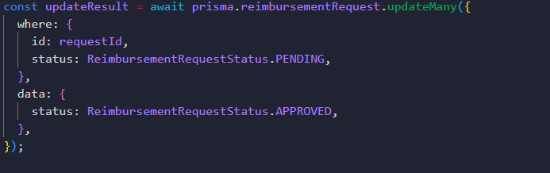
Figure 26. Prisma ORM Operation for Updating a Reimbursement Request

6.9.7 User Interface Implementation

6.9.7.1 Home Page
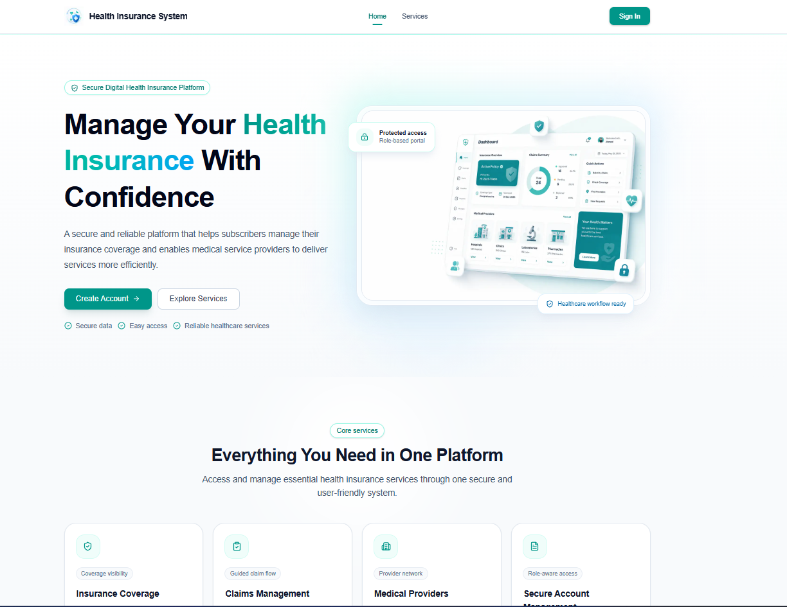
Figure 27. Home Page of the Health Insurance Management System
The interface presents the system identity, available services, and navigation options in a clear and responsive layout.

6.9.7.2 Sign-In Interface
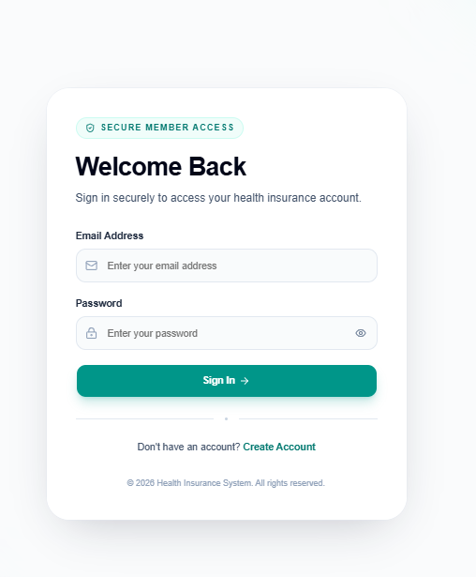
Figure 28. Sign-In Interface of the Health Insurance Management System
The interface validates the submitted credentials and displays a general error message when authentication fails. After successful authentication, the user is redirected according to the assigned role.

6.9.7.3 Subscriber Registration Interface

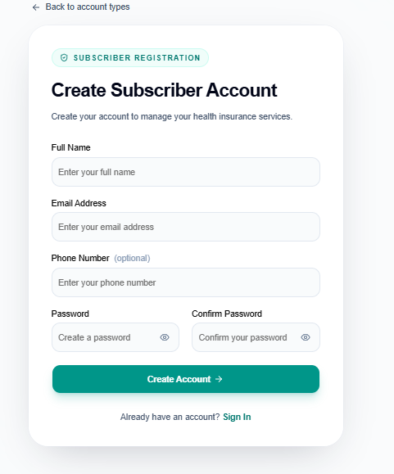
Figure 29. Subscriber Registration Interface
The interface collects the subscriber's full name, email address, optional phone number, password, and password confirmation. All submitted information is validated before the subscriber account is created.

6.9.7.4 Medical Service Provider Registration Interface
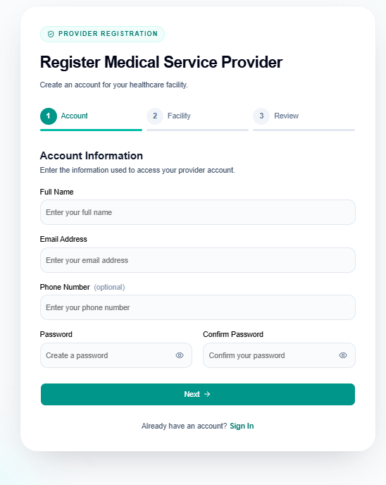
Figure 30. Medical Service Provider Registration Interface
The interface collects the provider's organization details, provider type, license number, contact information, and authentication credentials. The submitted information is validated before the provider account is created.

6.9.7.5 Insurance Plan Management Interface

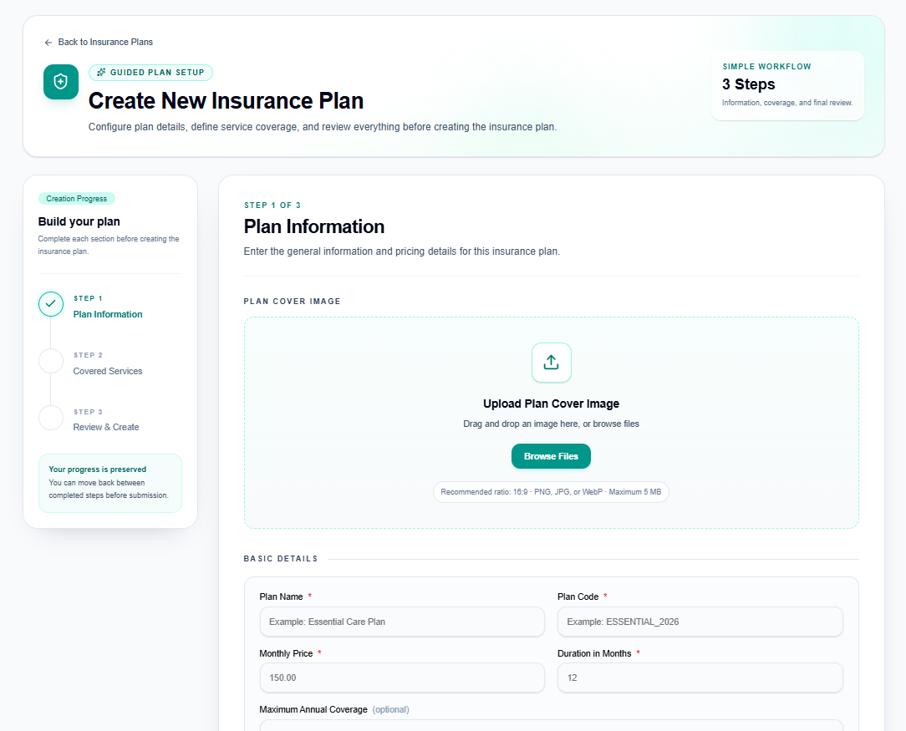
Figure 31. Insurance Plan Create Interface
The interface provides a structured form for entering the insurance plan details and defining the associated coverage records. Each selected medical service can be assigned a specific coverage percentage and an optional annual limit.

6.9.7.6 Subscription Activation Interface

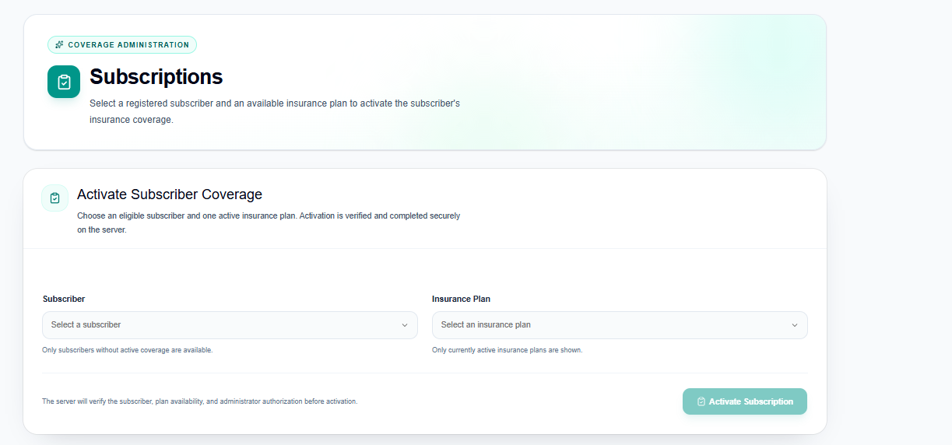
Figure 32 Subscription Activation Interface
The administrator selects a subscriber and an active insurance plan. The system validates the submitted information before creating or updating the subscriber's insurance subscription.

6.9.7.7 Reimbursement Request Interface
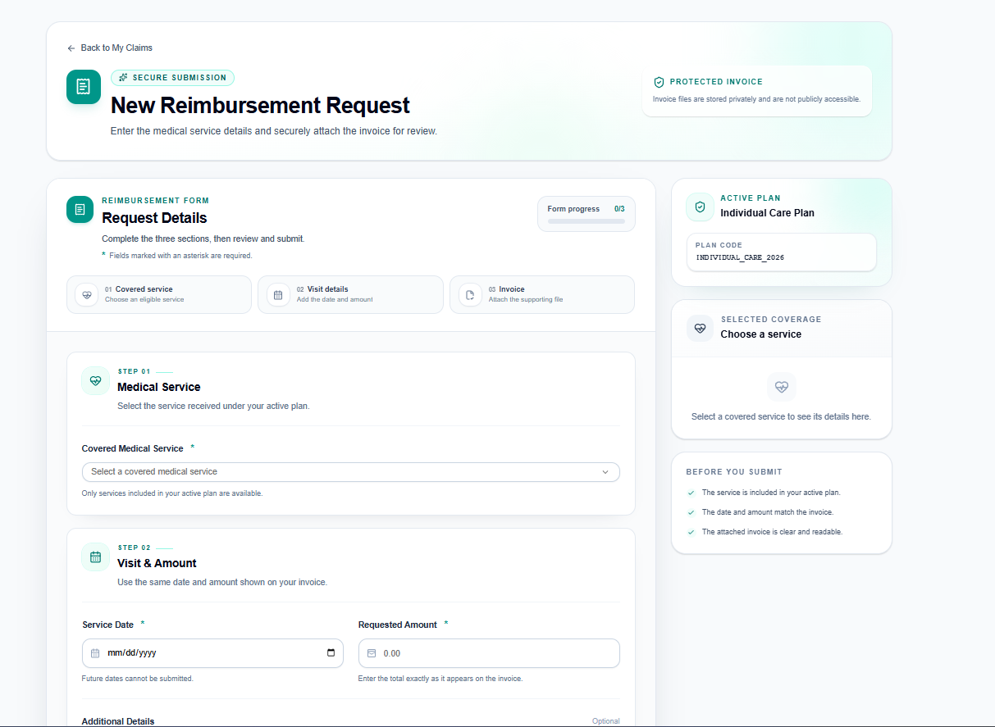
Figure 33. Reimbursement Request Interface
The subscriber enters the reimbursement details, selects the covered medical service, specifies the requested amount and service date, and uploads the supporting invoice before submitting the request.

6.9.7.8 Reimbursement Review Interface

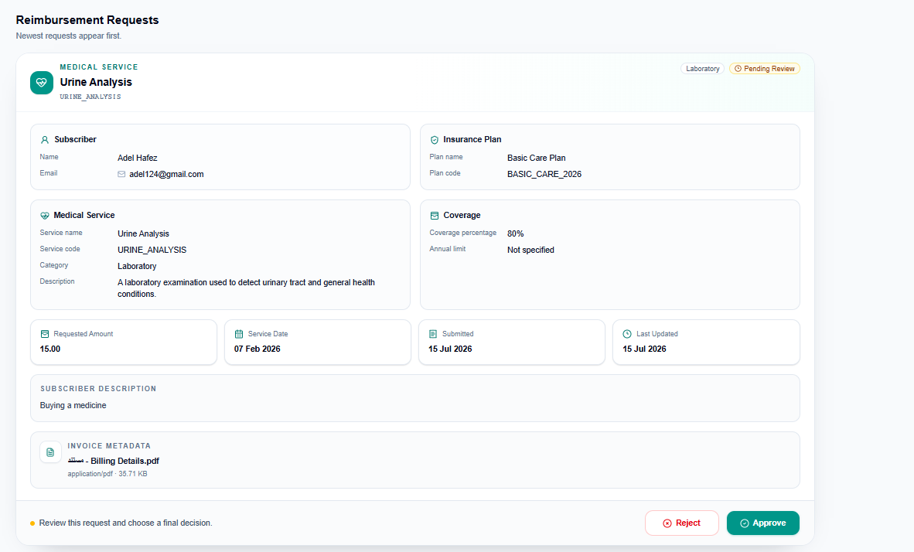
Figure 34. Reimbursement Review Interface

The administrator can review the reimbursement details and supporting documents before updating the request status to approved or rejected.

6.9.7.9 Subscriber Eligibility Verification Interface

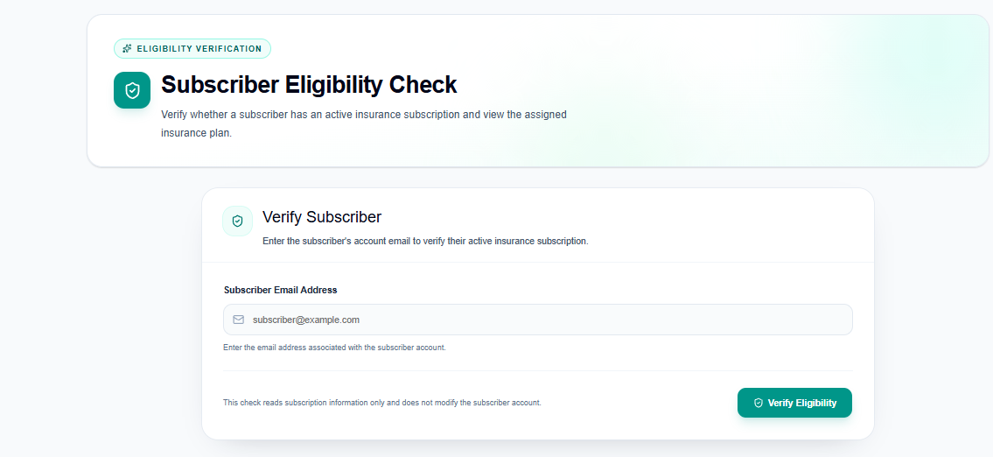
Figure 35. Subscriber Eligibility Verification Interface
The provider enters the subscriber's email address, and the system displays the eligibility status, subscription status, and insurance plan information when an active subscription exists.

6.10 Chapter Summary
This chapter presented the development environment and software implementation of the Health Insurance Management System. It described the development tools, programming languages, frameworks, database technologies, project structure, and representative implementation examples of the main system modules. The chapter also illustrated the implementation of the data access layer, application interfaces, and user interface through selected code excerpts and screenshots. These implementation details demonstrate how the proposed system was successfully developed to satisfy the specified functional and non-functional requirements.

Chapter 7: Testing and Evaluation

7.1 Test Plan
A test plan was prepared to organize the testing activities of the Health Insurance Management System. The plan defined the functions to be tested, the testing environment, the test data, the responsible testers, and the criteria used to determine whether each test was successful.
Testing was performed after implementing each functional increment and was repeated after integrating the modules into the complete system. The tests covered account creation and role-based login, insurance plan and coverage management, subscription activation, reimbursement request submission, request review and decision, and subscriber eligibility verification.
The testing activities were carried out manually in the local development environment using realistic sample data. Different accounts were used for the System Administrator, Subscriber, and Medical Service Provider roles. A test was considered successful when the actual result matched the expected result, the related database operation was completed correctly, invalid input was rejected, and unauthorized access was prevented.

7.2 Types of Testing
Three main types of testing were performed during the development of the Health Insurance Management System.

7.2.1 Module and Increment Testing
Each functional increment was tested separately after its implementation. The purpose of this testing was to verify that the functions of each module operated correctly before being integrated with the other modules. The tested increments included account creation and role-based login, insurance plan and coverage management, subscription activation, reimbursement request submission, reimbursement request review, and subscriber eligibility verification.

7.2.2 Integration Testing
After completing the main modules, integration testing was performed to verify that the modules interacted correctly with one another. This testing focused on data transfer between the user interface, business logic, data-access layer, database, and private document storage. It also verified that operations completed in one module were reflected correctly in the related modules.

7.2.3 System Testing
After integrating all modules, the complete system was tested through the different user roles. Full workflows were executed using the System Administrator, Subscriber, and Medical Service Provider accounts. The purpose was to verify that the Health Insurance Management System operated correctly as a complete application and satisfied the main functional requirements.

7.3 Test Diagrams

7.3.1 Functional Test Cases
The following test cases were derived from the functional requirements defined in Chapter 4. Each test case is linked to a specific requirement to verify that the corresponding system function operates correctly. The test cases include the test input or condition, the expected result, the actual result, and the final status.
Table 35. Functional Requirement Test Cases
Test Reference | Test Case Name | Test Input / Condition | Expected Result | Actual Result | Status
TC-01 / FR-01 | Create Subscriber Account | Valid subscriber name, email, password, phone number, and required registration data | A new subscriber account is created and stored successfully | Account created successfully | Passed
TC-02 / FR-02 | Create Medical Service Provider Account | Valid provider information, provider type, license number, email, and password | A provider account and medical provider profile are created successfully | Provider account and profile created successfully | Passed
TC-03 / FR-03 | Role-Based Login | Valid email and password for a System Administrator, Subscriber, or Medical Service Provider | The user is authenticated and redirected according to the assigned role | User authenticated and redirected correctly | Passed
TC-04 / FR-04 | Add New Health Insurance Plan | Valid insurance plan name, description, and required plan information | A new health insurance plan is created and stored in the database | Insurance plan created successfully | Passed
TC-05 / FR-05 | Define Covered Services and Coverage Percentages | Selected insurance plan, covered medical services, and valid coverage percentages | The selected services and coverage percentages are assigned to the insurance plan | Covered services and percentages assigned successfully | Passed
TC-06 / FR-06 | Activate Subscriber Subscription | Registered subscriber, available insurance plan, and valid subscription dates | An active subscription is created for the selected subscriber | Subscriber subscription activated successfully | Passed
TC-07 / FR-07 | View Subscription and Coverage Details | Subscriber account with an active insurance subscription | The system displays the subscription, insurance plan, covered services, and coverage percentages | Subscription and coverage details displayed correctly | Passed
TC-08 / FR-08 | Submit Medical Reimbursement Request | Valid reimbursement information submitted by a subscriber with an active subscription | A new reimbursement request is created with its initial status | Reimbursement request submitted successfully | Passed
TC-09 / FR-09 | Upload Invoices and Medical Documents | Valid invoice or medical document attached to a reimbursement request | The document is uploaded and associated with the correct reimbursement request | Document uploaded and linked successfully | Passed
TC-10 / FR-10 | Track Reimbursement Request Status | Subscriber account containing one or more reimbursement requests | The current status and details of each reimbursement request are displayed | The current status and details of each reimbursement request are displayed | Passed
TC-11 / FR-11 | Review Reimbursement Requests | System Administrator account and an existing reimbursement request | The administrator can view the request details and associated documents | Request and documents displayed correctly | Passed
TC-12 / FR-12 | Approve Reimbursement Request | Pending reimbursement request reviewed by the System Administrator | The request status is changed to approved and the decision is stored | Request approved and status updated successfully | Passed
TC-13 / FR-13 | Reject Reimbursement Request with Reason | Pending reimbursement request and a valid rejection reason | The request status is changed to rejected and the rejection reason is stored | Request rejected and reason stored successfully | Passed
TC-14 / FR-14 | Verify Subscriber Eligibility and Subscription Status | Subscriber email entered by a Medical Service Provider | The system displays whether the subscriber exists and has an active subscription | Eligibility and subscription status displayed correctly | Passed

7.3.2 Test Result Diagram
The following diagram summarizes the results of the executed functional test cases. A total of 14 test cases were performed to verify the main functional requirements of the Health Insurance Management System. All test cases passed successfully, and no failed cases were recorded.

Figure 36. Functional Test Case Results

7.4 Test Results and Analysis
A total of 14 functional test cases were executed to verify the main requirements of the Health Insurance Management System. All 14 test cases passed successfully, resulting in a success rate of 100%. No failed test cases or critical functional errors remained after completing the testing process.
The results confirmed that the implemented modules operated correctly both independently and after integration. The complete workflows were also tested through the System Administrator, Subscriber, and Medical Service Provider roles. The system correctly handled account creation, role-based login, insurance plan management, subscription activation, reimbursement request processing, document upload, and subscriber eligibility verification.
The successful results indicate that the main functional requirements defined in Chapter 4 were implemented correctly and that the modules interact properly within the complete system.

7.5 Quality Metrics
The quality evaluation was based on the results of the executed functional test cases. Since each functional requirement defined in Chapter 4 was linked to and verified by a corresponding test case, the test coverage was calculated based on functional requirement coverage. All 14 functional requirements were tested successfully, resulting in a test coverage of 100%. In addition, all executed test cases passed, and no critical functional errors remained after the testing process.
Table 36. Testing Quality Metrics
Quality Metric | Calculation | Result
Test Coverage | Tested functional requirements / Total functional requirements × 100 | 14 / 14 × 100 = 100%
Test Pass Rate | Passed test cases / Total test cases × 100 | 14 / 14 × 100 = 100%
Test Failure Rate | Failed test cases / Total test cases × 100 | 0 / 14 × 100 = 0%
Remaining Critical Errors | Number of unresolved critical errors | 0

7.6 User Testing
User testing was conducted with three users to evaluate the usability of the Health Insurance Management System and the clarity of its main workflows. Each user was assigned one of the three system roles: Subscriber, System Administrator, or Medical Service Provider.
Each participant was asked to perform the main tasks associated with the assigned role. The testing process was conducted through direct observation followed by a short discussion with each participant. The users’ ability to complete the required tasks, understand the interfaces, and interact with the available functions was observed. Their comments and suggested improvements were also recorded for further analysis.
Table 37. User Testing Participants and Assigned Tasks
User ID | Assigned Role | Main Tasks Performed | Evaluation Method | Test Outcome
UT-01 | Subscriber | Create an account, sign in, view subscription and coverage details, submit a reimbursement request, upload a document, and track the request status | Direct observation and short interview | Tasks tested and feedback collected
UT-02 | System Administrator | Sign in, add an insurance plan, define covered services and coverage percentages, activate a subscription, review requests, and approve or reject a request | Direct observation and short interview | Tasks tested and feedback collected
UT-03 | Medical Service Provider | Create a provider account, sign in, and verify subscriber eligibility and active subscription status | Direct observation and short interview | Tasks tested and feedback collected

7.7 Chapter Summary
This chapter presented the testing and evaluation activities conducted for the Health Insurance Management System. The testing process included module and increment testing, integration testing, and complete system testing through the different user roles.
A total of 14 functional test cases were executed and linked directly to the functional requirements defined in Chapter 4. All test cases passed successfully, resulting in a functional test coverage and test pass rate of 100%. No critical functional errors remained after completing the testing process.
User testing was also conducted with three participants representing the Subscriber, System Administrator, and Medical Service Provider roles. Each participant performed the main tasks associated with the assigned role, and feedback was collected regarding the clarity and usability of the system interfaces. Overall, the testing results confirmed that the implemented system functions operate correctly and satisfy the main functional requirements.

Chapter 8: Results and Analysis

Introduction
This chapter presents and analyzes the results achieved through the implementation of the Health Insurance Management System. It describes the main system functions and interfaces produced during the project, evaluates the achievement of the defined objectives, and compares the proposed system with traditional health insurance procedures. The chapter also discusses the main strengths and limitations of the implemented system and presents measurable indicators used to evaluate its overall performance.

8.1 System Implementation Results
The implementation of the project resulted in a functional prototype of the Health Insurance Management System. The system supports the main workflows of the three user roles: Subscriber, System Administrator, and Medical Service Provider. Separate role-based interfaces were implemented, and access to protected functions was restricted according to the assigned user role.
The implemented system provides account creation and role-based login, insurance plan and covered service management, subscriber subscription activation, reimbursement request submission with document upload, reimbursement request review and decision, and subscriber eligibility verification. These functions represent the main operational results achieved through the project.

8.1.1 Main Implemented Functions

Table 38. Main Implemented Functions
Implemented Module | Main Functions | Related Actors | Achieved Result
Account and Role-Based Login | Create subscriber and medical provider accounts, authenticate users, and redirect them according to their roles | Subscriber, System Administrator, Medical Service Provider | Users can securely access the functions assigned to their roles
Insurance Plan and Coverage Management | Create insurance plans, define covered medical services, and assign coverage percentages | System Administrator | Insurance plans and their coverage details can be created and managed
Subscription Activation | Link a registered subscriber to an insurance plan and define the subscription period | System Administrator | Subscriber insurance subscriptions can be activated and stored
Reimbursement Request Submission | Submit reimbursement requests, upload invoices or medical documents, and track request status | Subscriber | Subscribers can submit and monitor reimbursement requests digitally
Reimbursement Review and Decision | View submitted requests and documents, then approve or reject requests with a reason | System Administrator | Reimbursement requests can be reviewed and processed according to their status
Subscriber Eligibility Verification | Search for a subscriber and verify the existence of an active insurance subscription | Medical Service Provider | Medical providers can quickly verify subscriber eligibility and subscription status

8.1.2 Operational Results of the Implemented Interfaces
The screenshots of the main system interfaces were presented previously in Chapter 6 within the implementation section. These screenshots included the primary role-based interfaces and their related functions. Therefore, the same images are not repeated in this section to avoid redundancy. They are considered sufficient to represent the main operational results of the implemented system.

8.2 Comparative Analysis with Existing Systems
The proposed Health Insurance Management System was compared with traditional procedures in terms of workflow organization, information access, data accuracy, role-based access, and reimbursement tracking. The proposed system provides a centralized digital platform that connects the main user roles and supports the core insurance processes within one integrated system.
Table 39. Comparison Between the Proposed System and Traditional Procedures
Comparison Criterion | Traditional Procedures | Proposed System
Workflow Organization | Processes are performed through separate records and manual communication | Processes are organized within one centralized digital system
Access to Information | Information retrieval may require searching through paper or separate records | Authorized users can access the required information directly through role-based interfaces
Processing Speed | Completing insurance procedures may require several manual steps | Main procedures can be completed through integrated digital workflows
Data Accuracy | Manual data entry and repeated transfer of information may increase the possibility of errors | Validation rules and centralized data storage help reduce incorrect or incomplete records
Insurance Plan Management | Plans and coverage details may be maintained in separate documents | Plans, covered services, and coverage percentages are managed within the system
Subscription Activation | Subscription status may require manual recording and verification | Administrators can activate subscriptions and store their status electronically
Reimbursement Request Submission | Requests and documents may be submitted and followed through manual procedures | Subscribers can submit requests, upload documents, and track their status digitally
Reimbursement Request Review | Reviewing requests may require collecting information from different records | Administrators can review request details and attached documents through one interface
Eligibility Verification | Medical providers may need manual communication to confirm subscriber eligibility | Medical providers can verify subscriber eligibility and active subscription status directly
Role-Based Access | Access permissions may not be clearly separated between users | Each user can access only the functions permitted for the assigned role
Document Handling | Invoices and medical documents may be stored separately from request records | Uploaded documents are linked to the corresponding reimbursement requests
Request Tracking | Subscribers may have limited visibility of request progress | The current request status can be viewed through the subscriber interface
Operational Cost | Manual procedures may require more paper records and administrative effort | The digital system reduces dependence on paper-based records and repeated manual operations

8.3 Achievement of Project Objectives
The project objectives defined in Chapter 1 were reviewed and compared with the implemented and tested system functions. The results showed that the main objectives related to centralized health insurance management, role-based access, insurance plan and subscription management, reimbursement request processing, and subscriber eligibility verification were achieved successfully.
The following table presents each project objective, the evidence of its achievement, and its final status.
Table 40. Achievement of Project Objectives
Objective ID | Project Objective | Evidence of Achievement | Status
OBJ-01 | To develop a role-based authentication system that allows subscribers, system administrators, and medical service providers to access the functions related to their roles. | Role-based authentication and authorization were implemented. Each user is redirected to the appropriate interface and can access only the permitted functions. | Achieved
OBJ-02 | To create a health insurance plan management module that enables the system administrator to add new insurance plans and manage their basic information. | The System Administrator can create insurance plans and store their names, descriptions, and related information in the database. | Achieved
OBJ-03 | To enable the system administrator to define the covered medical services within each insurance plan and specify the coverage percentage for each service. | The coverage management module allows covered medical services and their coverage percentages to be assigned to each insurance plan. | Achieved
OBJ-04 | To enable the system administrator to activate a subscriber’s insurance subscription, including subscription status and validity period. | The subscription management module enables the administrator to link a subscriber to an insurance plan and define the subscription status and validity period. | Achieved
OBJ-05 | To allow subscribers to view their subscription details, covered medical services, and coverage percentages related to their insurance plan. | The Subscriber interface displays the active subscription, insurance plan information, covered services, and related coverage percentages. | Achieved
OBJ-06 | To allow subscribers to submit new medical reimbursement requests and attach supporting invoices or medical documents. | Subscribers can submit reimbursement requests and upload invoices or medical documents associated with each request. | Achieved
OBJ-07 | To provide a request tracking feature that allows subscribers to follow the status of their reimbursement requests as Pending, Approved, or Rejected with a reason. | The request tracking interface displays the current request status and shows the rejection reason when a request is rejected. | Achieved
OBJ-08 | To enable the system administrator to review medical reimbursement requests and approve or reject them based on the submitted data and uploaded documents. | The administrator can view request details and documents and can approve or reject each request with a recorded decision. | Achieved
OBJ-09 | To allow medical service providers to verify subscriber eligibility and subscription status before providing covered medical services. | The eligibility verification module allows medical service providers to check whether a subscriber exists and has an active insurance subscription. | Achieved
OBJ-10 | To produce a working software prototype that demonstrates the main workflow of the Health Insurance Management System by the end of the project period. | A functional software prototype containing the main modules and workflows was implemented, integrated, and successfully tested. | Achieved

8.4 Strengths and Weaknesses Analysis
This section presents the main strengths and limitations of the implemented system.
Table 41. Strengths and Weaknesses of the Implemented System
Category | Point | Analysis
Strength | Centralized workflow | The system integrates insurance plans, subscriptions, reimbursement requests, and eligibility verification within one digital platform.
Strength | Role-based access | Each user can access only the functions related to the assigned role.
Strength | Integrated reimbursement processing | Subscribers can submit requests and documents, while administrators can review and process them through the system.
Strength | Subscription and eligibility verification | Subscription information can be viewed by subscribers and verified by medical service providers.
Strength | Layered and modular architecture | The separation of the presentation, business logic, data-access, and database layers support maintenance and future development.
Strength | Input validation and error handling | The system validates submitted data and displays appropriate messages for invalid or incomplete inputs.
Weakness | Local deployment | The current prototype operates in a local development environment and has not been deployed to a production server.
Weakness | Use of sample data | The system was tested using realistic sample data rather than real health insurance records.
Weakness | Limited external integration | The system is not currently integrated with hospitals, insurance companies, payment services, or government systems.
Weakness | Limited user testing | User testing was conducted with only three participants, one for each system role.

8.5 Key Performance Indicators (KPIs)
The system was evaluated using measurable indicators related to the project objectives, requirements, and testing results. The results confirmed the successful implementation of the main functions.

Table 42. Key Performance Indicators
KPI | Measurement | Result | Interpretation
Objective Achievement Rate | Achieved objectives / Total objectives × 100 | 10 / 10 × 100 = 100% | All project objectives were achieved
Functional Requirement Coverage | Tested requirements / Total functional requirements × 100 | 14 / 14 × 100 = 100% | All functional requirements were covered by test cases
Test Pass Rate | Passed test cases / Total test cases × 100 | 14 / 14 × 100 = 100% | All executed test cases passed
Module Completion Rate | Completed modules / Planned modules × 100 | 6 / 6 × 100 = 100% | All planned functional modules were implemented
User Role Coverage | Tested roles / Total system roles × 100 | 3 / 3 × 100 = 100% | All system roles were included in user testing

8.6 Chapter Summary
This chapter presented the results achieved through the implementation of the Health Insurance Management System. The results showed that the system supports the main workflows of the three user roles within one centralized digital platform. The comparison also demonstrated that the proposed system provides better organization of data and processes than traditional procedures.
The project objectives defined in Chapter 1 were reviewed and confirmed through the implemented functions. The main strengths and current limitations of the system were also identified. Finally, the key performance indicators confirmed the successful achievement of the project objectives, functional requirements, and testing targets.

Conclusion
The purpose of this project was to design and develop a Health Insurance Management System that organizes the main insurance operations within one centralized digital platform. A role-based system was implemented to support Subscribers, System Administrators, and Medical Service Providers. The system enables insurance plan and coverage management, subscription activation, reimbursement request processing, and subscriber eligibility verification.
The project contributed to the practical application of software engineering principles through requirements analysis, system modeling, database and architectural design, incremental implementation, and testing. The main functional requirements were implemented and verified through fourteen test cases. All test cases passed successfully, confirming the correctness and integration of the core system functions.
The results showed that the system provides better organization of data and workflows than traditional procedures. However, the current system remains an academic prototype operating in a local environment and using sample data. It is not yet integrated with external insurance companies or medical institutions, and user testing was conducted with a limited number of participants.
The main challenges included the limited project period, the lack of real health insurance data, and the need to model business processes and role-based permissions accurately. Future development may include production deployment, electronic notifications, integration with medical institutions and insurance companies, and broader automated and user testing.
Overall, the project achieved its main objectives and produced a functional software prototype that demonstrates how core health insurance operations can be transformed into organized and extensible digital workflows.

